**Unreal Engine Pinball**

Name: Trunesh Loke

Roll No : 1824008

IT- A

LY

**Table of Contents**

1. Assignment 1 Date: 5/06/2020 - 07/06/2020 Date Submitted:06/06/2020
   1. To make the base for the pinball game
2. Assignment 2 Date: 7/06/2020 – 11/06/2020 Date Submitted: 11/06/2020
   1. Text should appear “ball came near me” when the ball enter in the Bumper sphere collision (overlap
   2. To make the Ball go in upward direction in appropriate speed also stick to the ground while going in upward direction.
3. Assignment 3 Date: 12/06/2020-14/06/2020 Date Submitted: 14/06/2020
   1. Set up the plunger movement.
   2. Make material for flippers
4. Assignment 4 Date: 14/06/2020-15/06/2020 Date Submitted: 15/06/2020
   1. Spawn the ball thrice on the Plunger.
5. Assignment 5 Date: 21/06/2020-23/06/2020 Date Submitted: 23/06/2020
   1. Make spline using the SM_Rail, SM_RailMid, SM_RailMouth
   2. Make Ramp using spline via using SM_RampNoTop.FBX and SM_PlasticRamp_End.FBX
6. Assignment 6 Date: 25/06/2020-26/06/2020 Date Submitted: 26/06/2020
   1. Set up the Decals using T_Decalpack_01 , Three decals as following: Straight Arrow, Curve Arrow, Pinball Board Corner Decal
7. Final Mini Project Date:28/06/2020-06/07/2020 Date Submitted: 06/07/2020
   1. Set up the Bonus region which should be in such position such as ball should pass through below , as well as Small bumpers should be included in the region and small hole to pass the ball.
   2. Make Central region, which includes the three Bumpers and have the path so that ball can pass through easily.
   3. Set up the Cannon which Shoots the ball in high speed.
   4. Make Ball teleport to the Ramp start position which goes towards to the bonus region.
   5. Set up two plungers which should work at the same time after hitting spacebar.
   6. Add sounds to the different Components, widgets , Blueprints Etc.

**Assignment 1**

* To Make the base for the pinball game

**Description:**

In this assignment, pinball base should be made, the length should be X=3600 and Width should be Y=2600 and Height Z=100

On the border of the pinball base the length of X=3600, width Y=200 and height of Z=200 box geometry should be place respective to border length X=3600. Same for the width having length of X=2600

Base should be necessary for the pinball game, this is where all the components and different blueprints will be place such as flippers, bumpers, Plunger etc. in the sense complete pinball game will be inside the plunger.

**Objective:**

1. Objective of this assignment is to start understanding the Unreal engine very basic features such as the adding geometry brush and moving it.
2. Creating geometry brush from existing one via pressing the Alt key and by dragging it at the same time.

**Result:**

1. First added the geometry box from left side panel, Set Its scale to X=3600 and Y=2600, Set Its height to Z=100

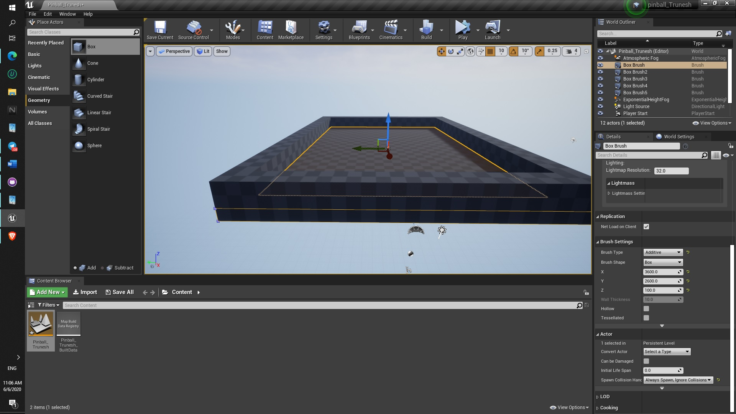

1. Now those long square boxes also made with geometry box, their scale is X=3600, Y=200, Z=200, they are placed manually perfectly.

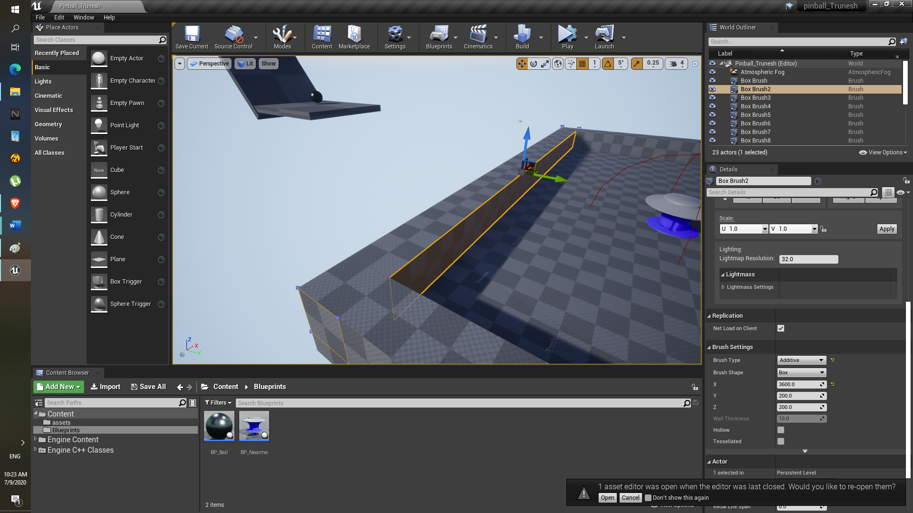

1. Now those (Width )long square boxes also made with geometry box, their scale is X=2600, Y=200, Z=200

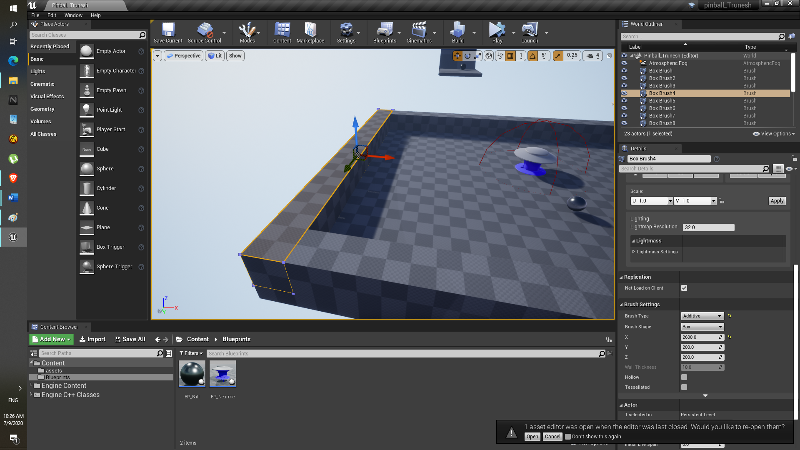

1. Now for others are dragged via pressing the Alt key, so duplicate can be made.

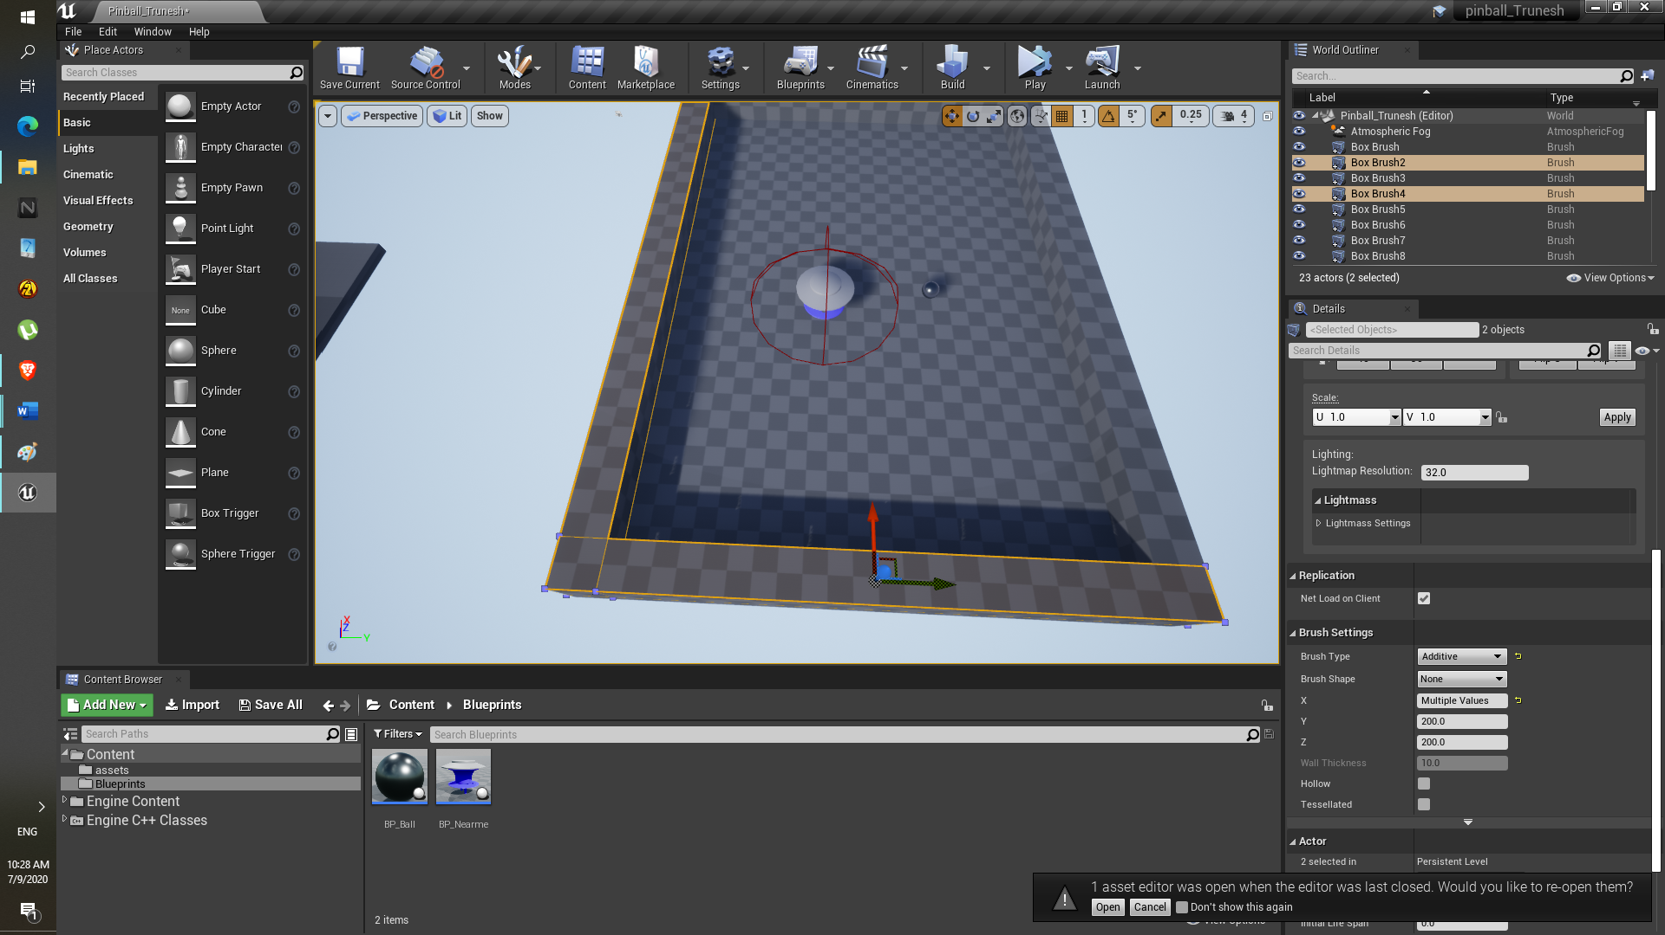

**Difficulty:**

None

**Assignment 2**

* After enter in the bumper region, Text should appear “ball came near me”
* Ball should stick to the ground while moving through upwards slope and should gain speed as well as stick to the ground.

**Description:**

After enter in the bumper region, Text should appear “ball came near me”.

Ball should stick to the ground while moving through upwards slope and should gain speed as well as stick to the ground.

Also, we need to create the Bumper and Ball blueprints to do so.

To make the ball move in opposite direction after hitting the bumper. first we need to identify whether or not ball got near bumper itself or not.

The ball should not fly from the pinball game base, that’s why the second task is given.

**Objective:**

1. Understanding the basic of blueprints in the unreal engine.
2. Importing static mesh from the pinball assets folder.
3. Creating blueprints and adding Collision overlap to the Blueprints and identifying whether or not after ball gets in the region.
4. Adding collision to the ballsphere itself.
5. In UE using add impulse component and linetraceby component add the impulse to the ball via making it stick to the ground.

Task 1: After enter in the bumper region, Text should appear “ball came near me”

**Result:**

1. Bumper mesh is imported from the pinball asset.

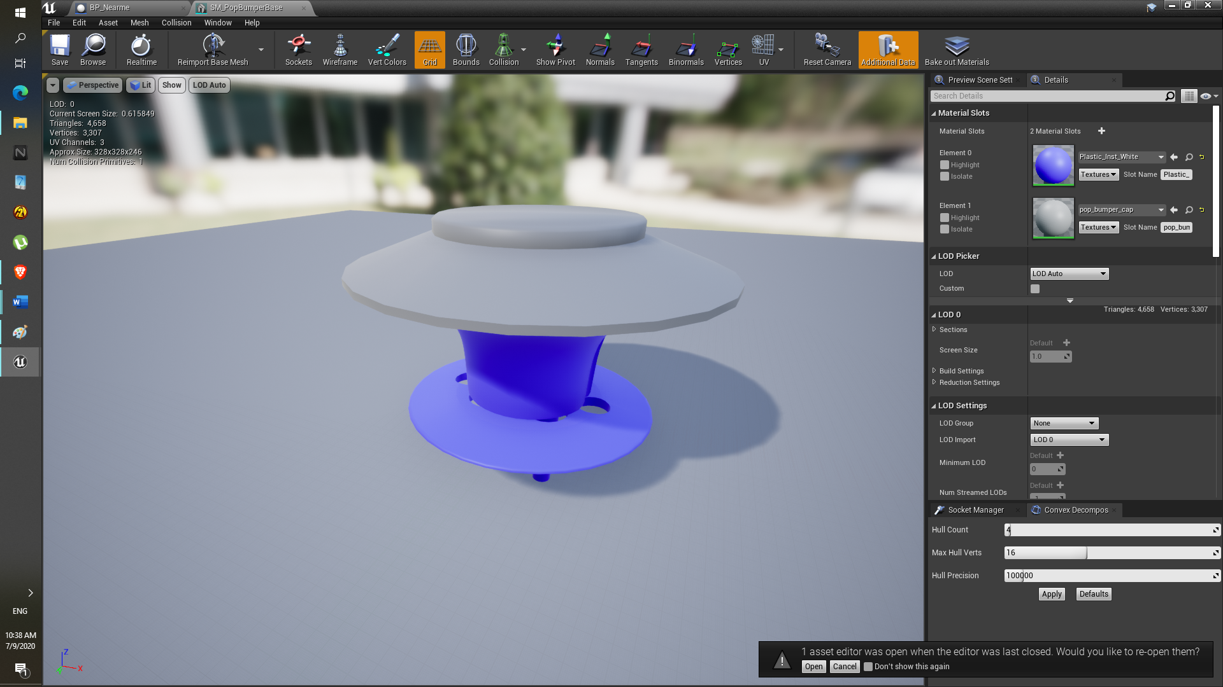

1. So blueprint class is created via right click on blueprint folder and Actor class is selected.

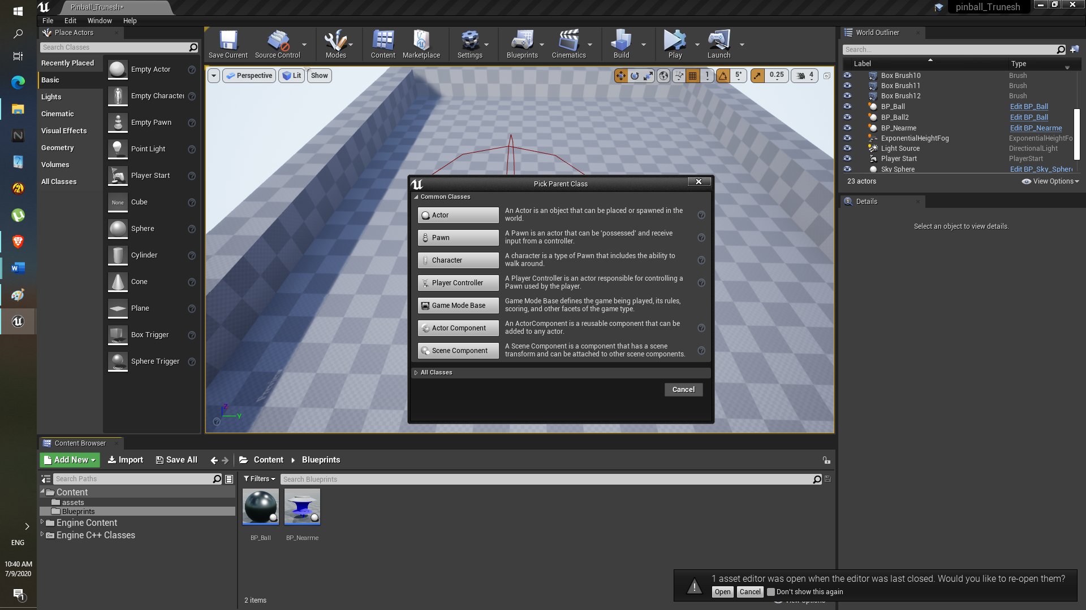

1. Inside blueprint click on viewport ,then left side there is option to Add Component , the add static mesh.
2. After adding static mesh click on it, on the right side there iis option to add the Static mesh, Drop down menu type the asset name here “SM_Popbumperbase”.
3. Again add component , added “sphere collsiion” and adjust according to size.

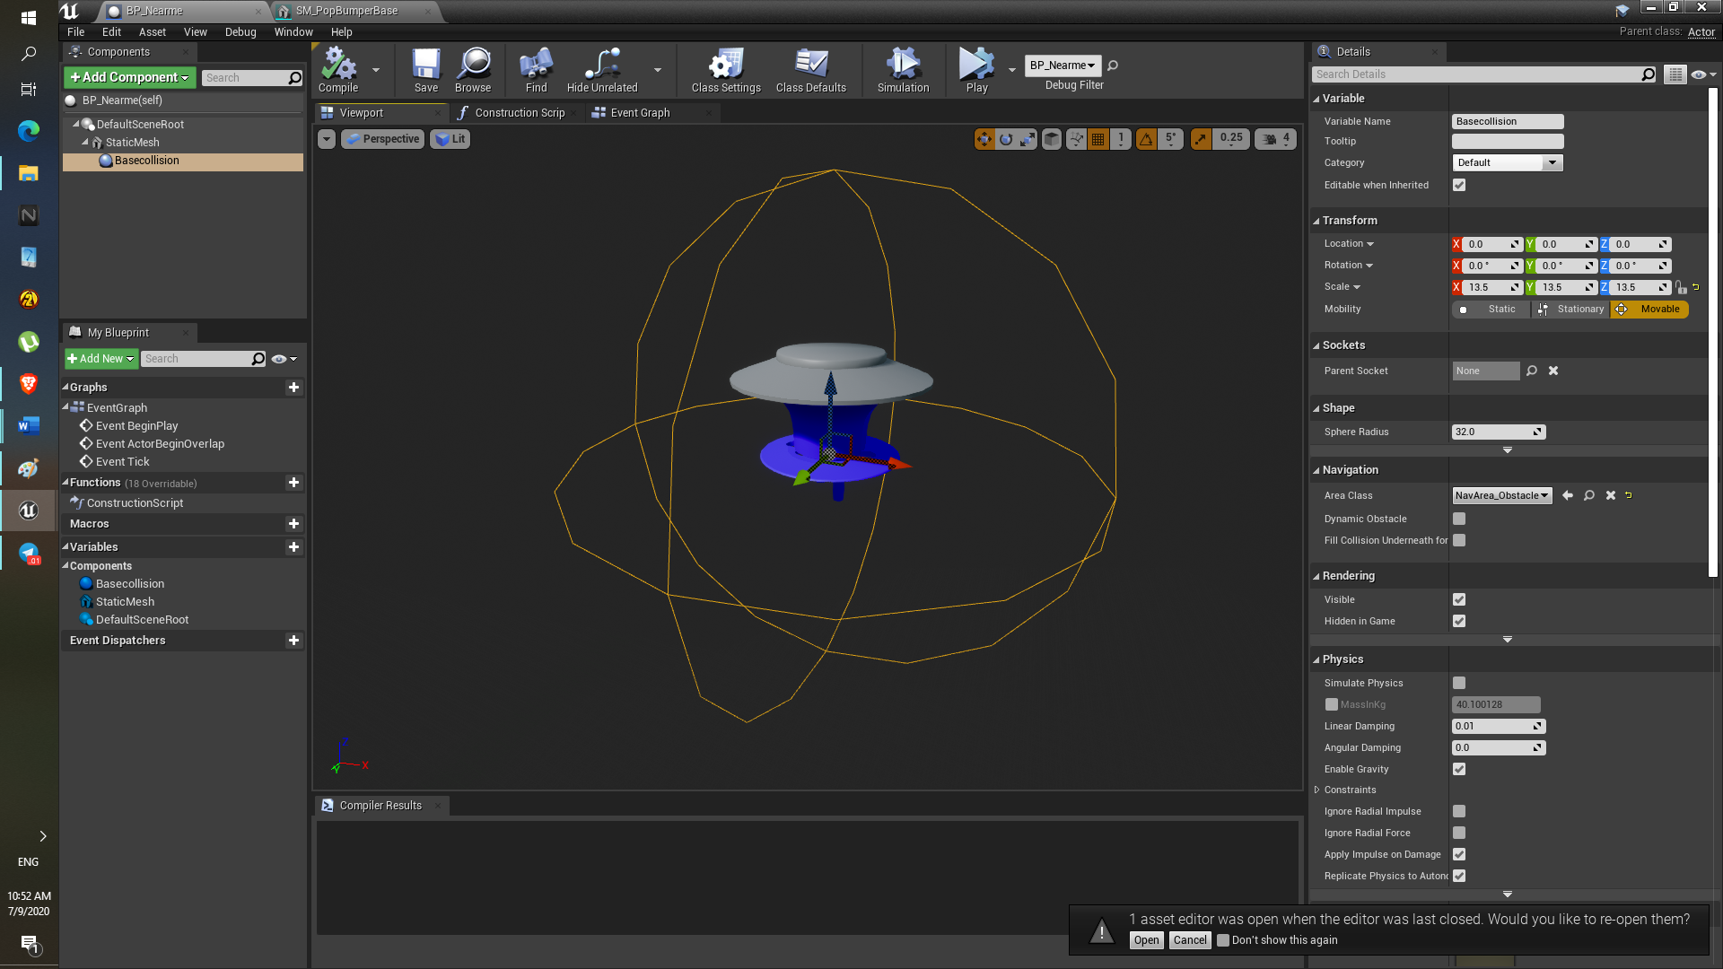

1. After that in the event graph tab, the Event Action begin overlap the print string component is added to print the text. Inside print string box “Ball just came near me” In string can be set.

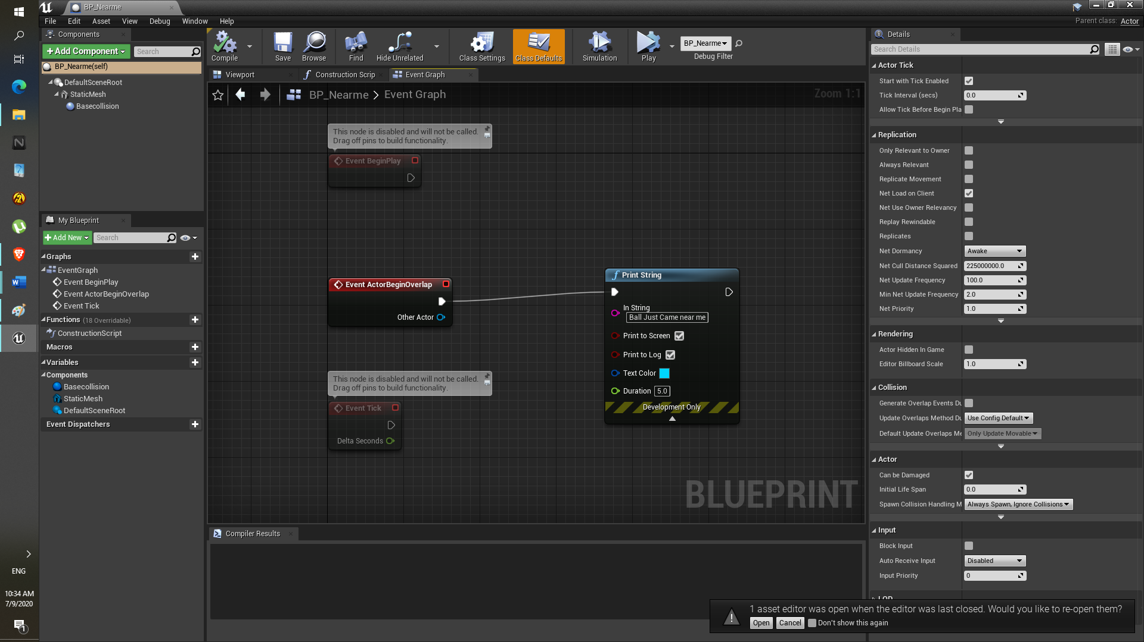

**Results:**

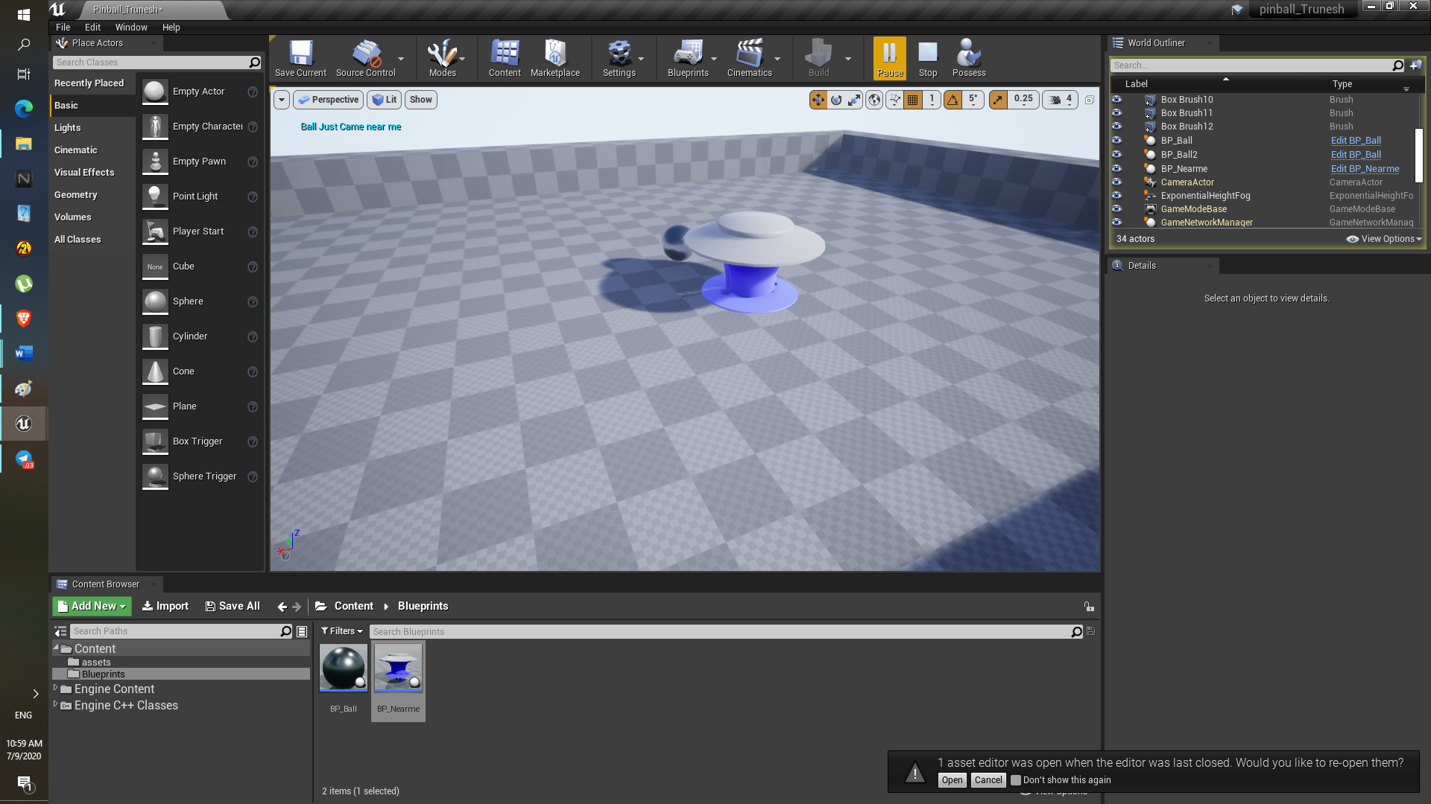

**Difficulty:**

None

Task 2: Ball should stick towards ground and gain speed at the same time. Ball should stick to the ground even while going through upwards slope

Results:

1. First asset is ballsphere from the pinball asset and material is applied. To it from right panel.

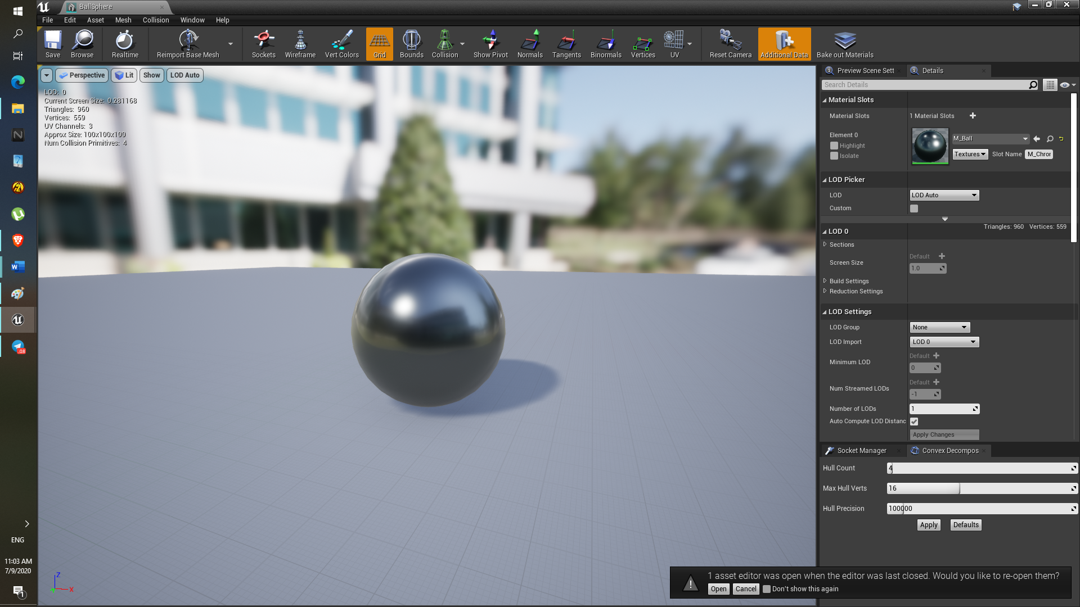

1. Material set as follows, via pressing left mouse click and “1” key from keyboard the both constants are added into material, and one constant join with the metallic attribute and another join with the roughness. Roughness makes 0 makes the ball complete reflective.

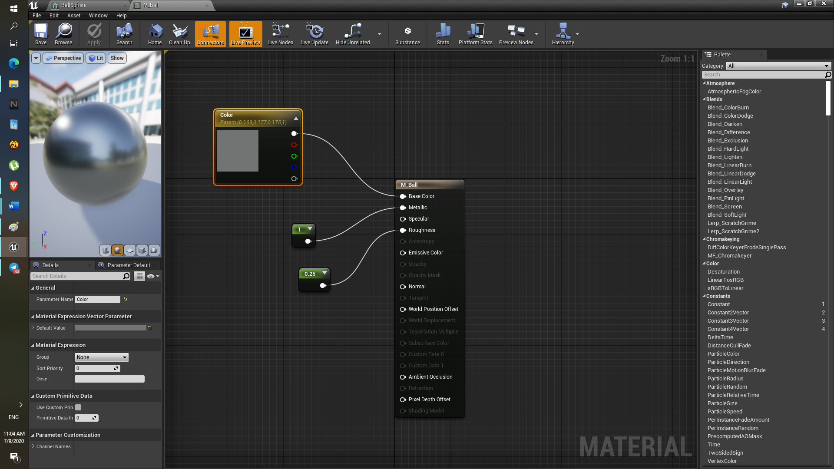

1. Inside the Ball blueprint in the event graph, via linetrace ball can stick to the ground, we are creating start to end linetrace via actor location and from actor location the vector value X=0 Y=0 Z=5050 is subtracted, that means in upwards direction. ( in the sense in result will be positive Z) and now.
2. But after Out hit result we are multiplying the impact normal with “negative 1” so that what’s makes the ball to go down and linetrace below z=5050 in downward direction. for each event tick, the -vector impact normal is multiplied with the ‘table stickyness’ to keep the ball stick to the ground. 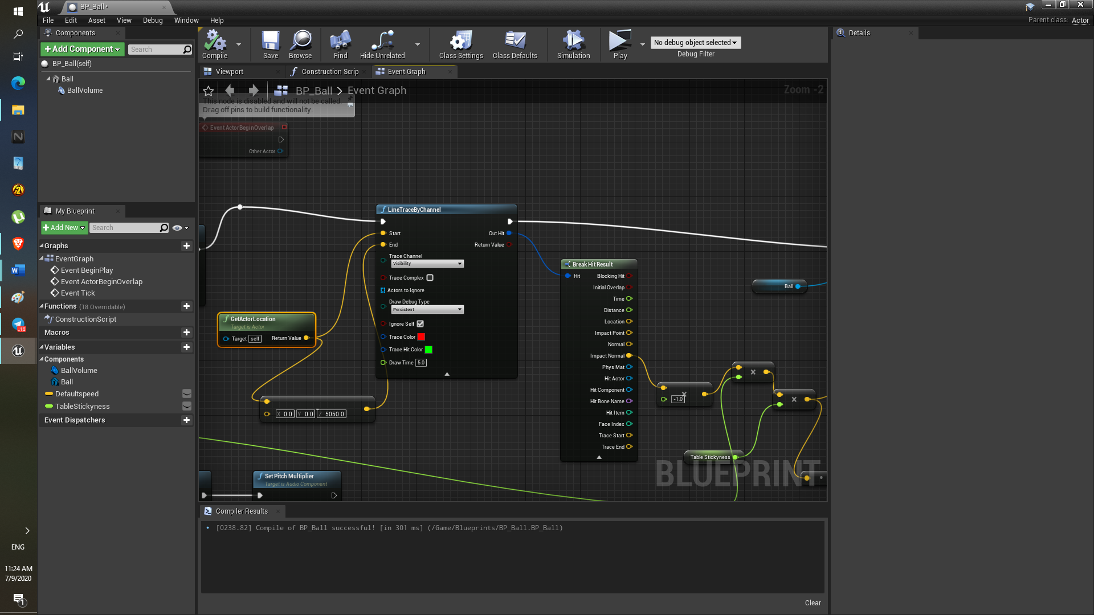
3. As for the green line , it’s the delta event tick ( that’s when if some lag is produced to keep up with the machine specs.. it is used, ball location will be trace properly after adding impulse.
4. Impulses are added via add impulse component and vector ‘Default Speed’ vector value is set to X=0 Y=2600 Z=-55

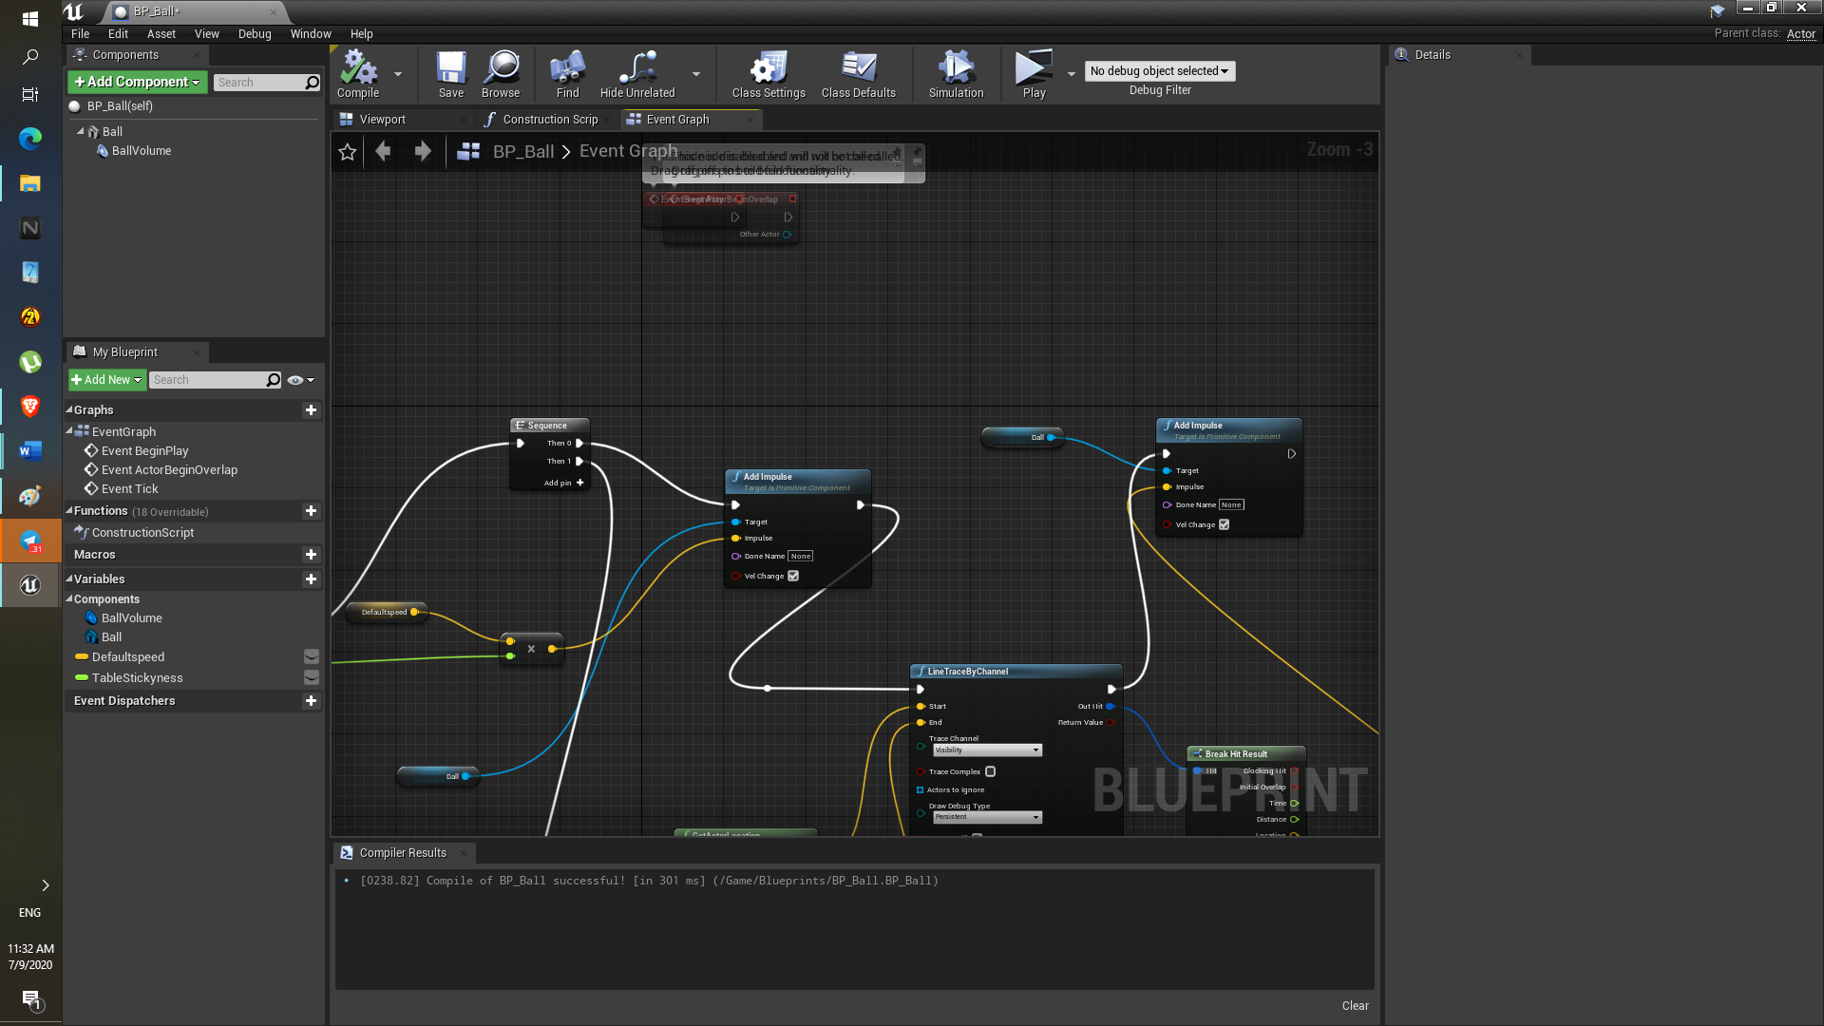

**Results:**

As in picture the line trace is shown that even ball goes in at 2600 speed, it still stick to the ground because of linetrace by channel.

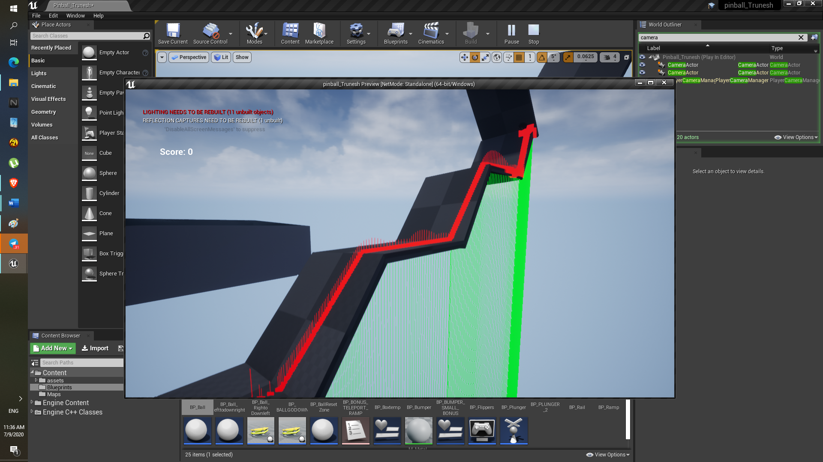

**Difficulty:**

Understanding the linetracebychannel component in the starting was bit difficult, so after solution is shown on lecture video it done properly. What I did before use linetracebychannel correctly and ball correctly stick to the ground but did not add the impulse before linetracebychannel.

Assignment 3

* Set up the Plunger at proper location and it should move after hitting spacebar.
* Make material for the flippers.

**Description:**

Here we have to add the plunger static mesh from the pinball assets and also made the blueprint for the plunger itself. The plunger should be added at the right side of the pinball game base.

It should work after hitting space bar going backwards via holding space bar and after releasing the spacebar it should go in opposite direction.

Also, in this assignment the materials for the flipper should be made.

**Objective:**

1. Learn to add the physical collision to the static mesh via using the Static mesh
2. Get familiar with the Input modes from the project properties.
3. Use of subtractive geometry box and make the proper region for the plunger.
4. Copying existing geometry brush and paste it and make it transform mirror X for the pinball destroy region
5. Learn to use of enumerate and make blueprint for flippers.
6. Create material for the flipper to get to know Unreal engine Materials.

**Results:**

1. After importing the SM_Plunger asset from the pinball assets using static mesh editor added the simplified collision.

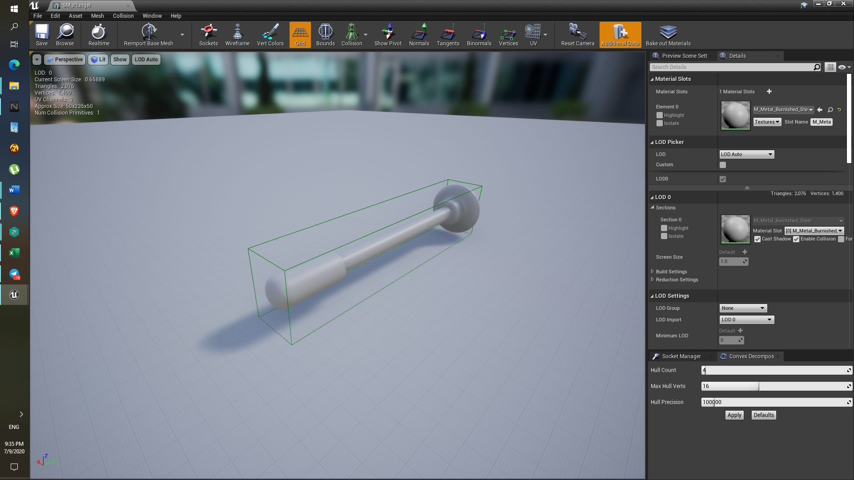

1. Input edited from project settings added the action mapping spacebar PushPlunger.

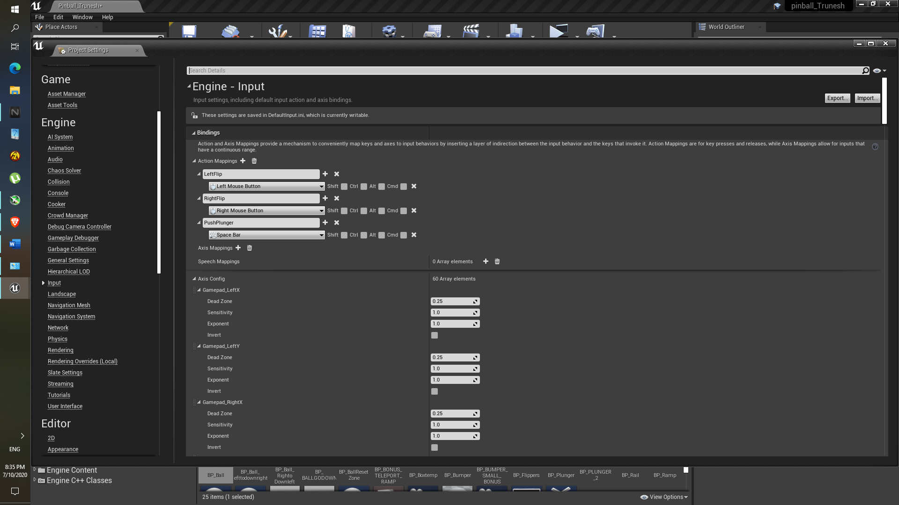

1. In event graph the lerp is used so that, the plunger will move back from its original position to the specified position at given above timeline.

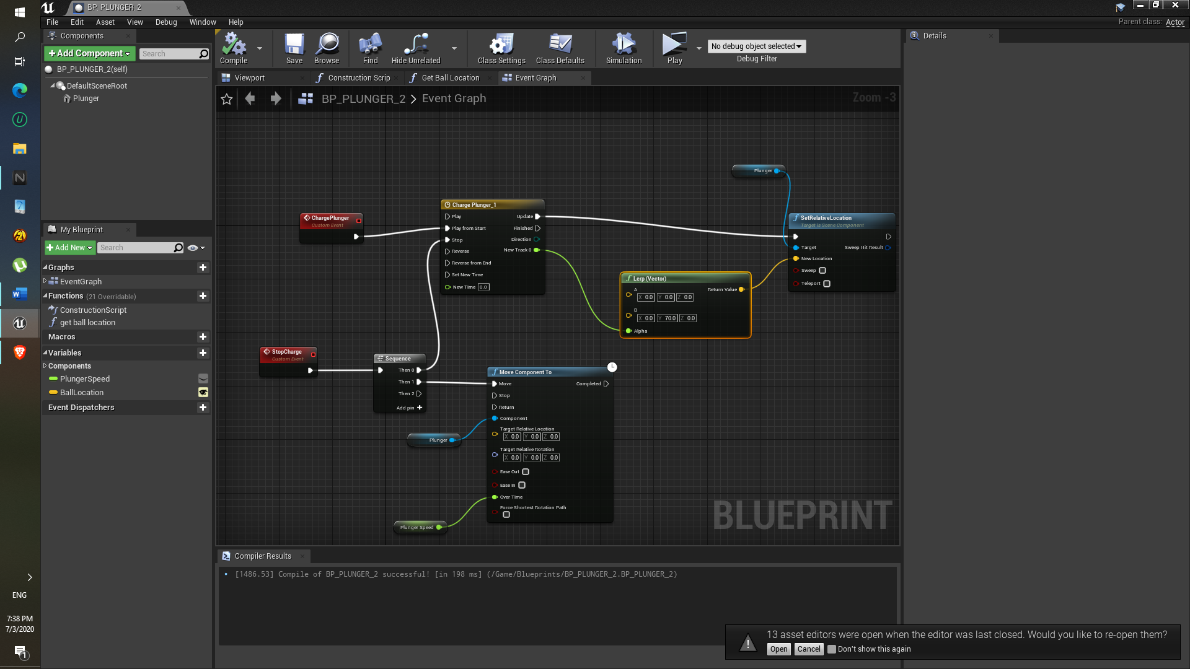

1. As soon as spacebar is released the move component will move plunger to its original position.
2. Get ball location component is used to spawn the ball.
3. In pinball game mode the Spawn component is created, in that function the ‘Spawn actor from class’ is used to spawn the actor at particular transform/ position, that component uses ‘Get ball location’.

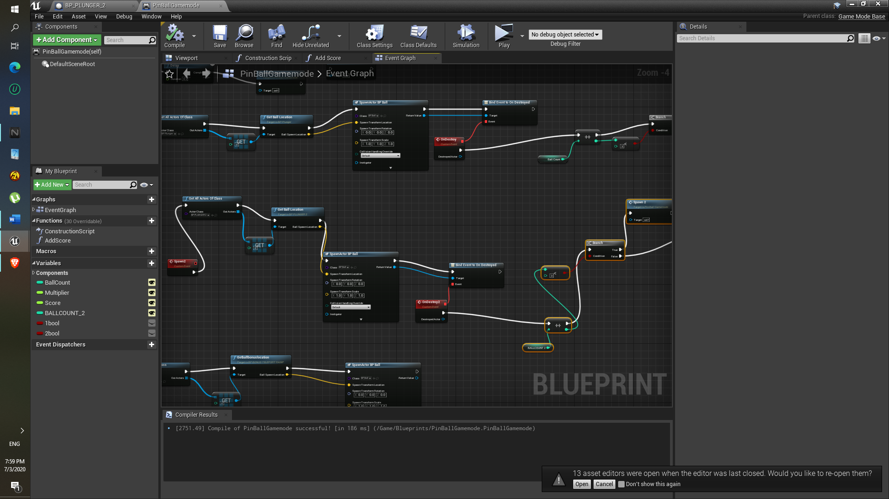

1. To end the game, I simply added to Booleans and check them after getting ball count upto 3. For both plunger that means total 6 balls.

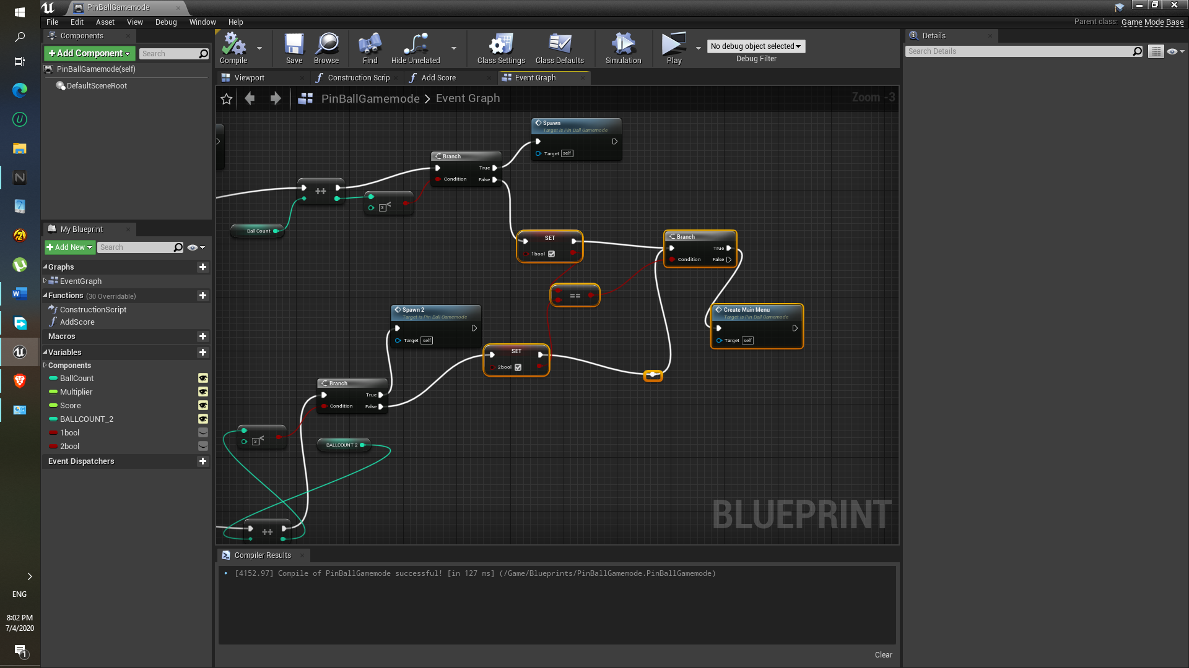

1. Added sounds to the when plunger is charge, that is when Spacebar is hold and when it is released.

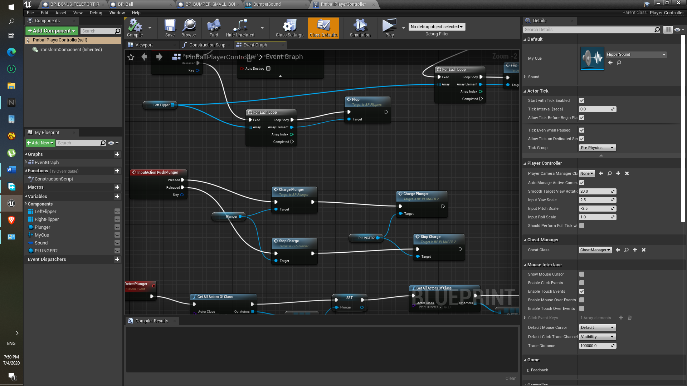

Flippers and Flipper Material:

1. Left Flipper and Right Flipper should be move in upward direction as soon as assign left key ( can be any here left mouse button is used) and right key ( here right mouse button) is pressed respectively.
2. Reason we used only one blueprint for the both left and right flippers the enumerate is used.

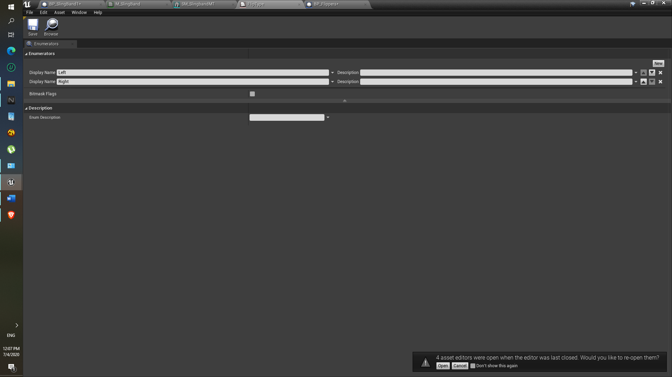

1. We have to set the Construction script for the flipType enumerator so that in specified rotation specified flipType(left or right) will move accordingly.

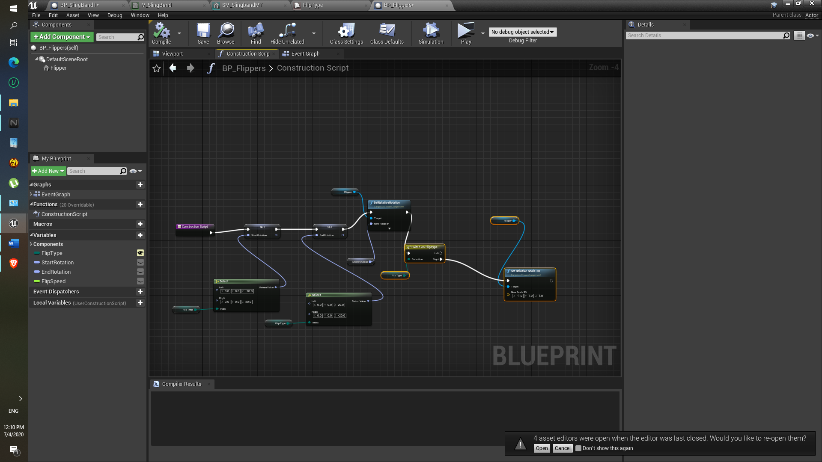

1. As for the rotation for the both flippers 20 degrees are used and switch on flipType is used to distinguish between right and left flipper. The mirror X-axis is assign to -1 so that left flip type i.e. left flipper can become Right flipper after assigning FlipType.
2. Move component is used to get the rotation at initial position and also to assign the flipSpeed.

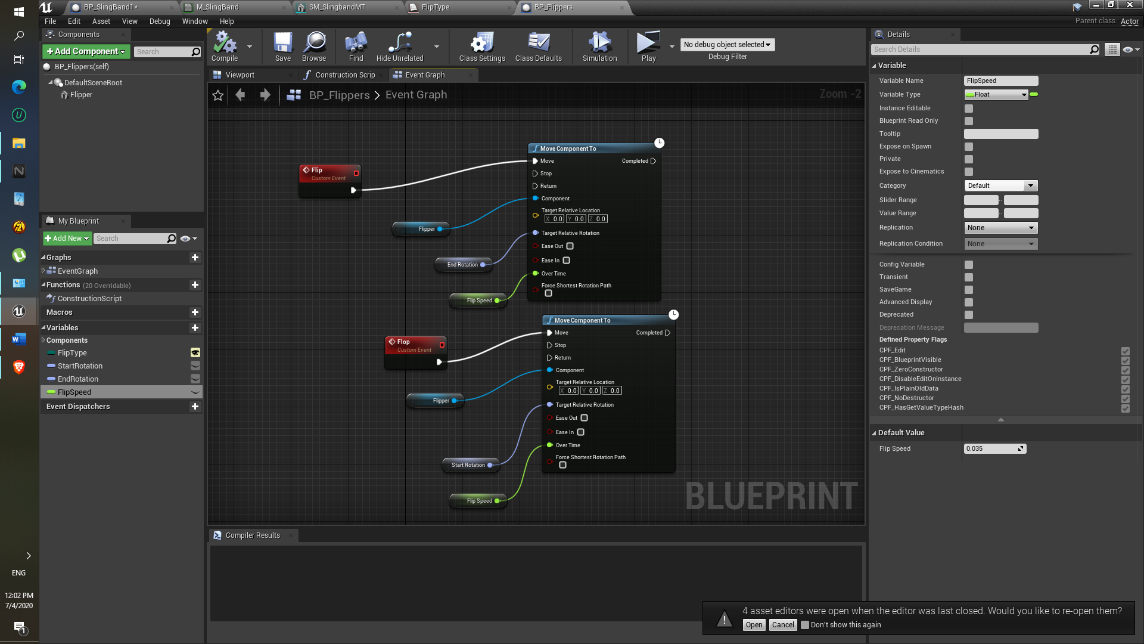

1. As for material for flipper made as follows:

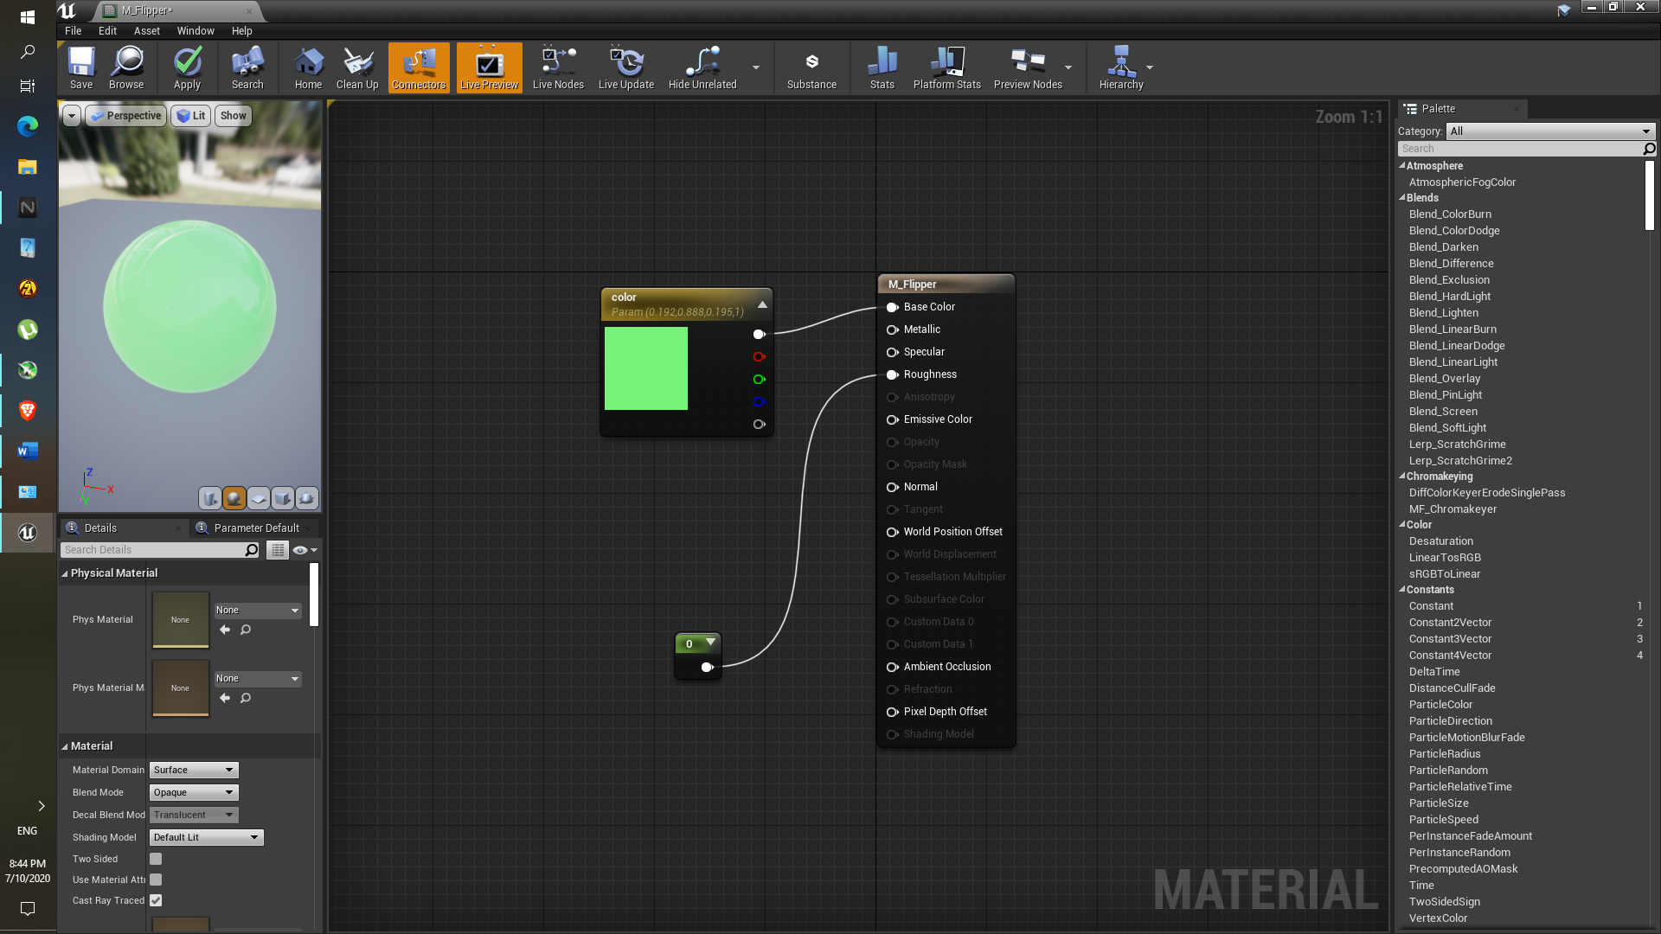

1. Material flipper rubber:

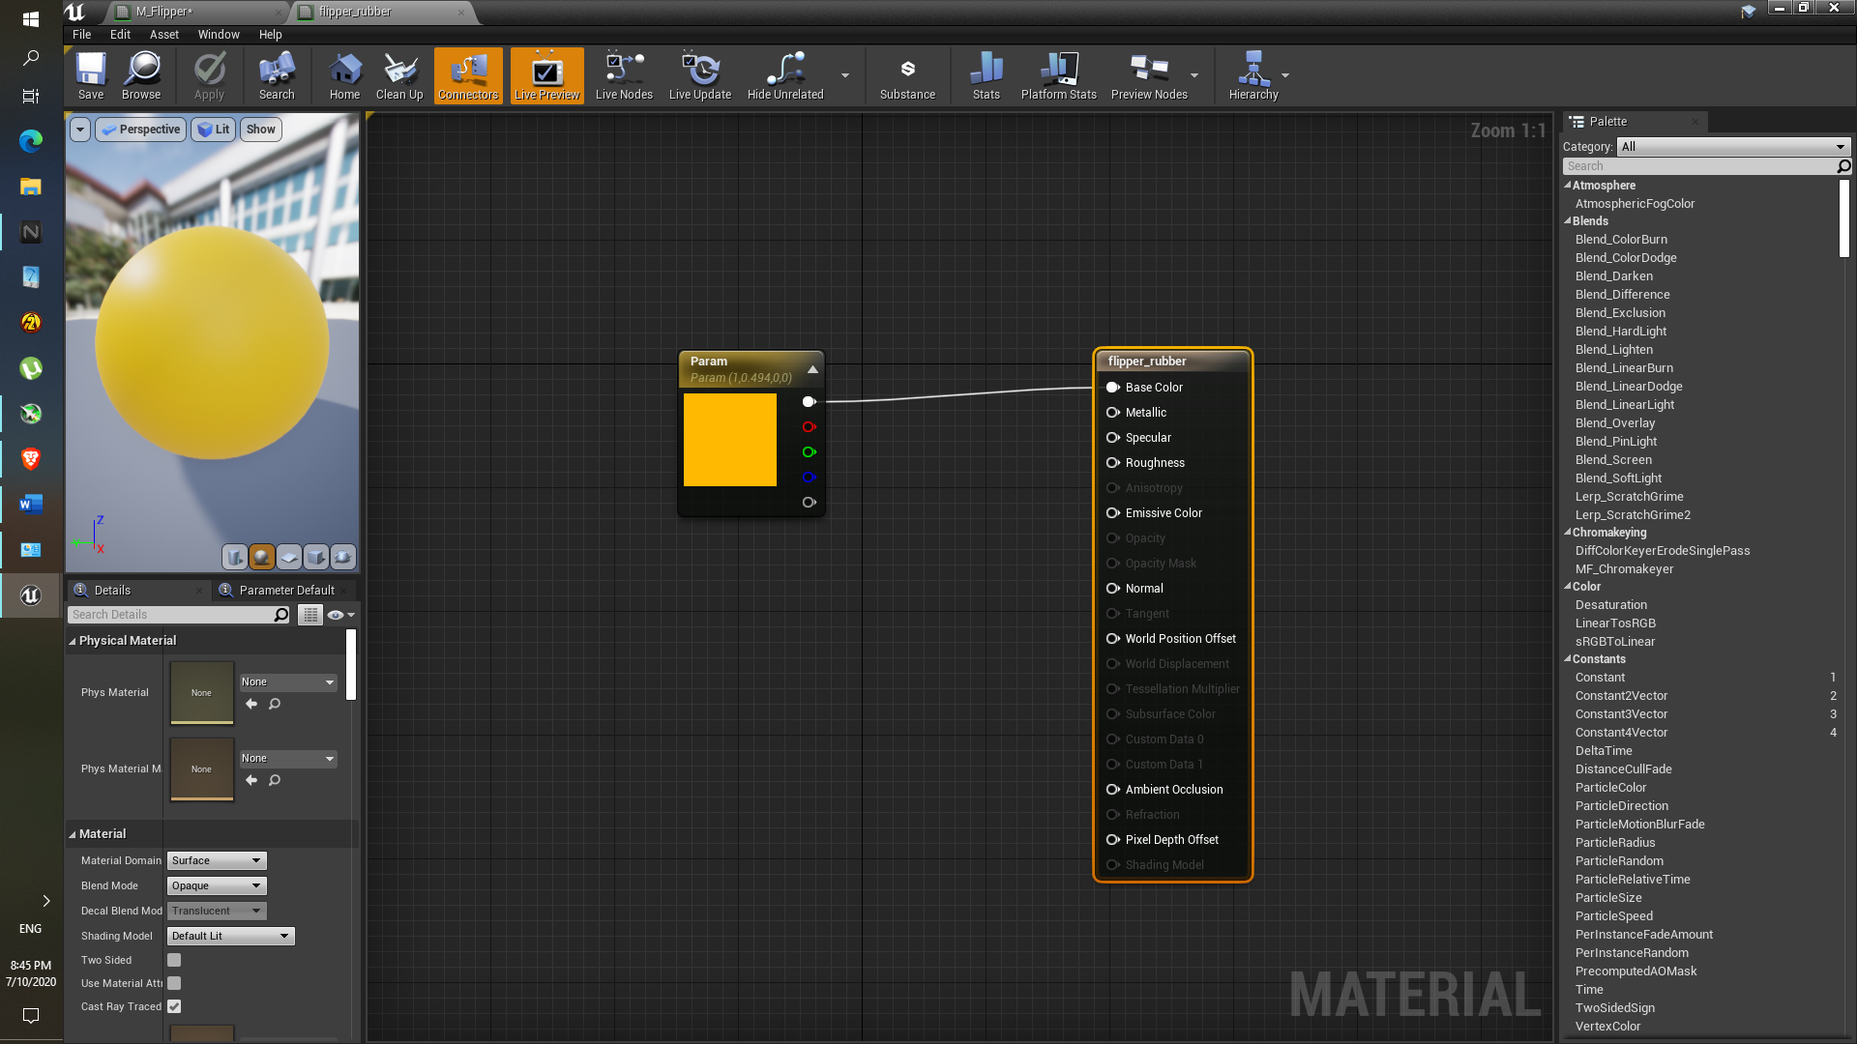

1. Now this is how current flipper looks like.

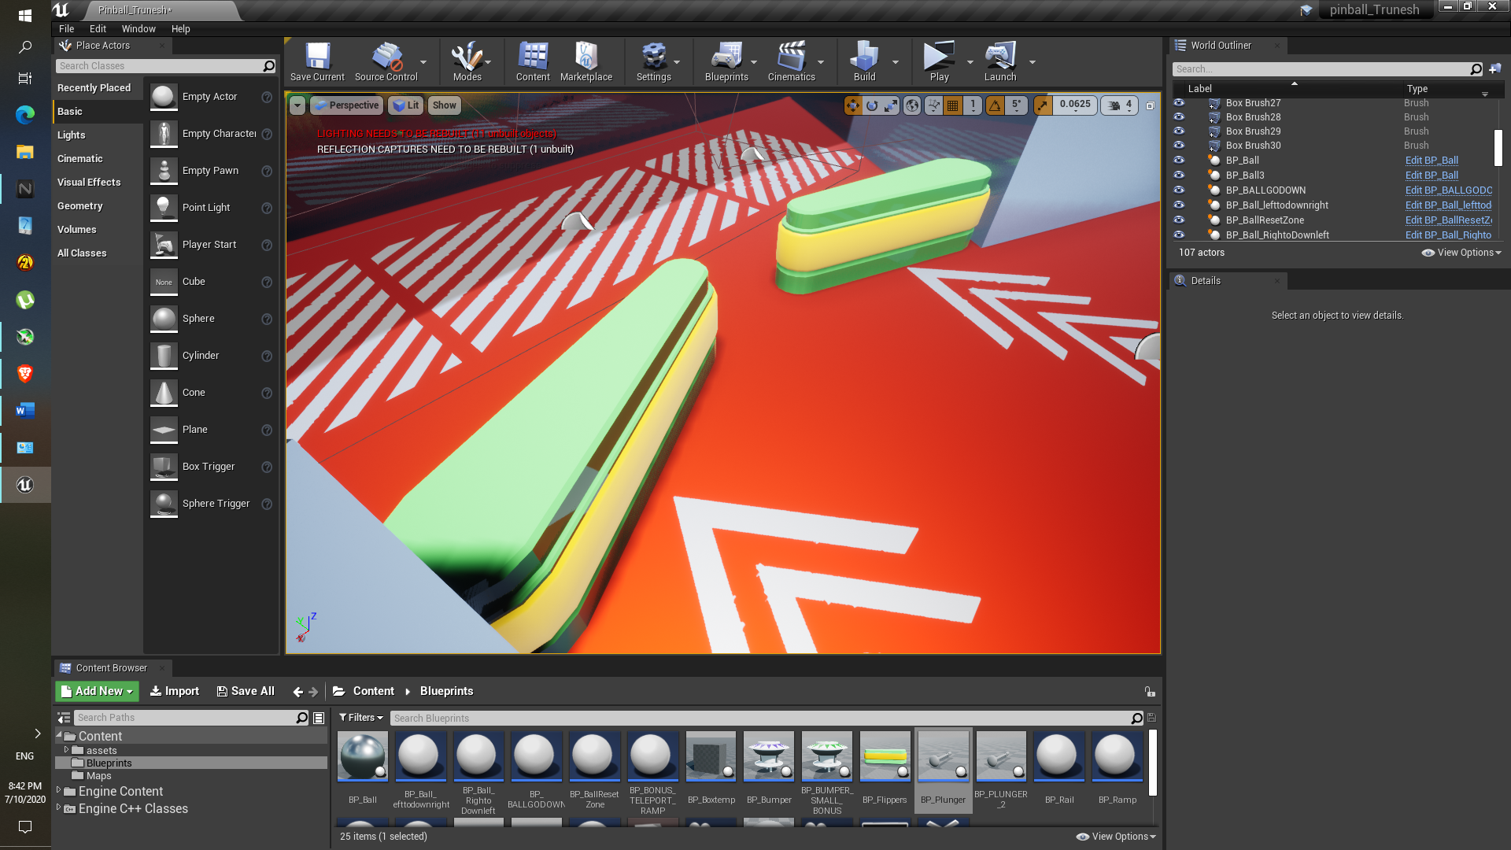

Difficulty:

1. Plunger was flying off for some reason, later I realized that we have to disable the Simulate physics. So, it won’t fly off.
2. Actually flip Type rotation was not appropriate, same for the both FlipType(Right and left showing exact same rotation) , it is fixed later after realizing the rotation angle.

Assignment 4

Spawn the ball thrice on the Plunger after immediately came across in the BallResetzone.

**Description:**

In this assignment we have to spawn the ball after getting vanish by ‘BallResetZone’ (that is after losing ball below flippers.

Here ball get the spawn on the plunger immediately after the ball get inside the ‘BallResetZone ‘below the flippers. Here the ‘Destroy actor’ component is used to destroy actor with the help of casting.

Casting is necessary to determine whether or not ball has entered in the ‘BallResetZone’. After ball gets inside it, the ball which has entered that ball should be vanish and spawn another ball on the top of the Plunger with the help of 3d widget and get transform to get the ball location.

**Objective:**

1. Learn Casting component in the unreal engine.
2. Learn to use the 3d widget from the blueprint.
3. Learn to use the get actor transform to get actor locations.
4. Understanding the use of relational operators.

**Results:**

1. This is blueprints which is used the box Collison.

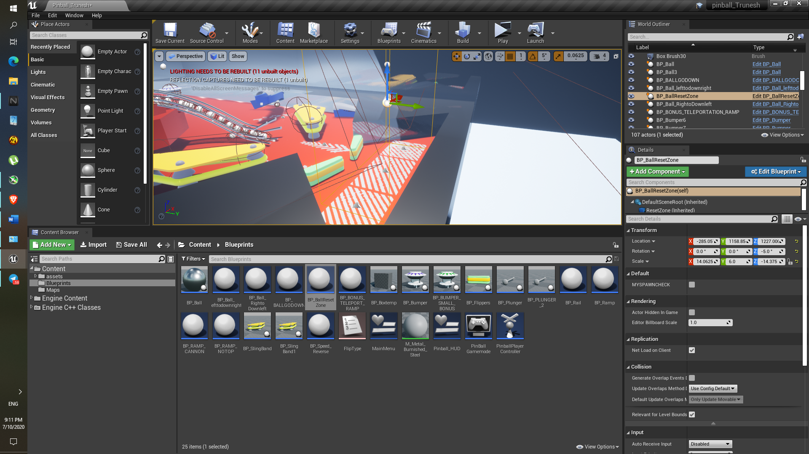

1. In the event graph the Cast To BP_ball is used to check whether ball has entered in that ‘Box collision’ overlap.

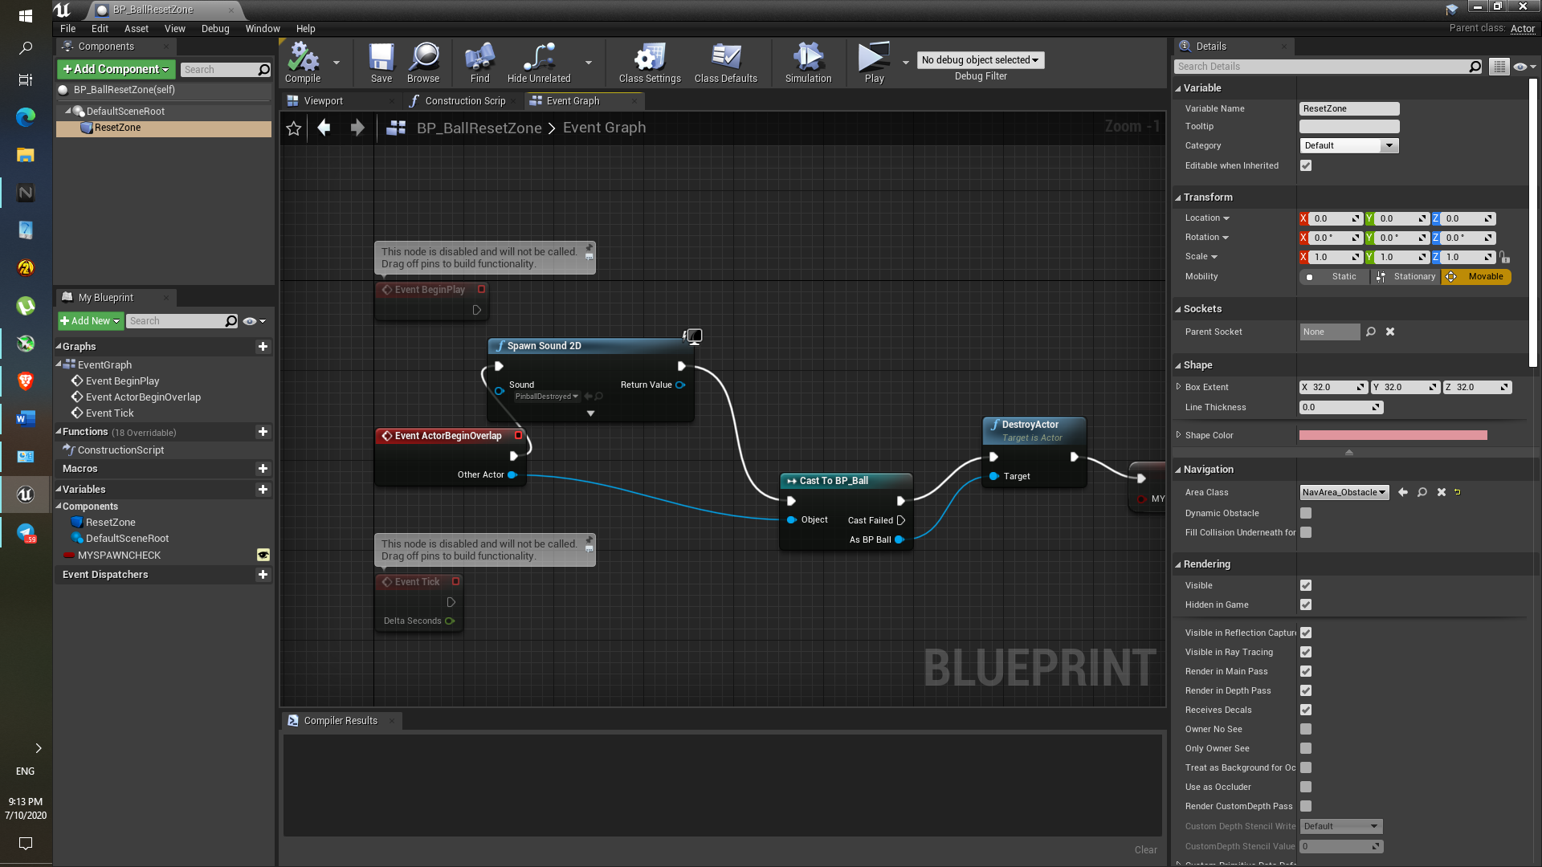

1. This is Components are resides in the Pinballgamemode with the help of bind on destroy event the spawn function will work, to work ball spawn only thrice the condition is applied, if the ball count is below 3 only then function will work.

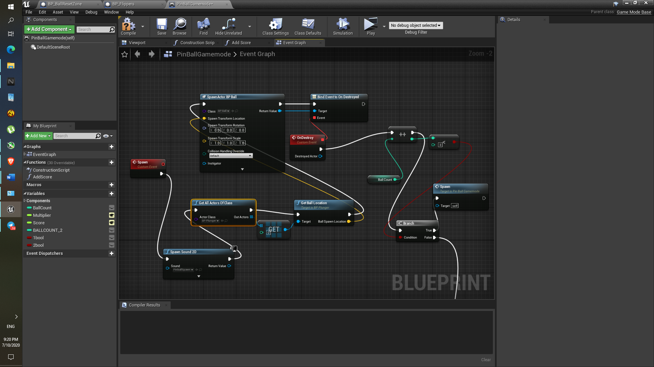

**Difficulty:**

None

Assignment 5

* Make spline using the SM_Rail, SM_RailMid, SM_RailMouth
* Make Ramp using spline via using SM_RampNoTop.FBX and SM_PlasticRamp_End.FBX

**Description:**

In this assignment the we have to make desire path such that the ball can go through it, and it should be easily travel within that path. Here we are going to use the Rail as well as ramp.

This assignment was necessary to create the Rail path and Ramp, and to understand how can we create curve path using Spline component.

**Objective:**

1. Understanding the ‘Spline’ component from the viewport.
2. Build desire path using Rail and Ramp static mesh.

**Results:**

1. In the for loop if we run the construction script, and if the index is 0 then ‘Rail mouth’ static mesh will be added, if the very first spline point is extended.

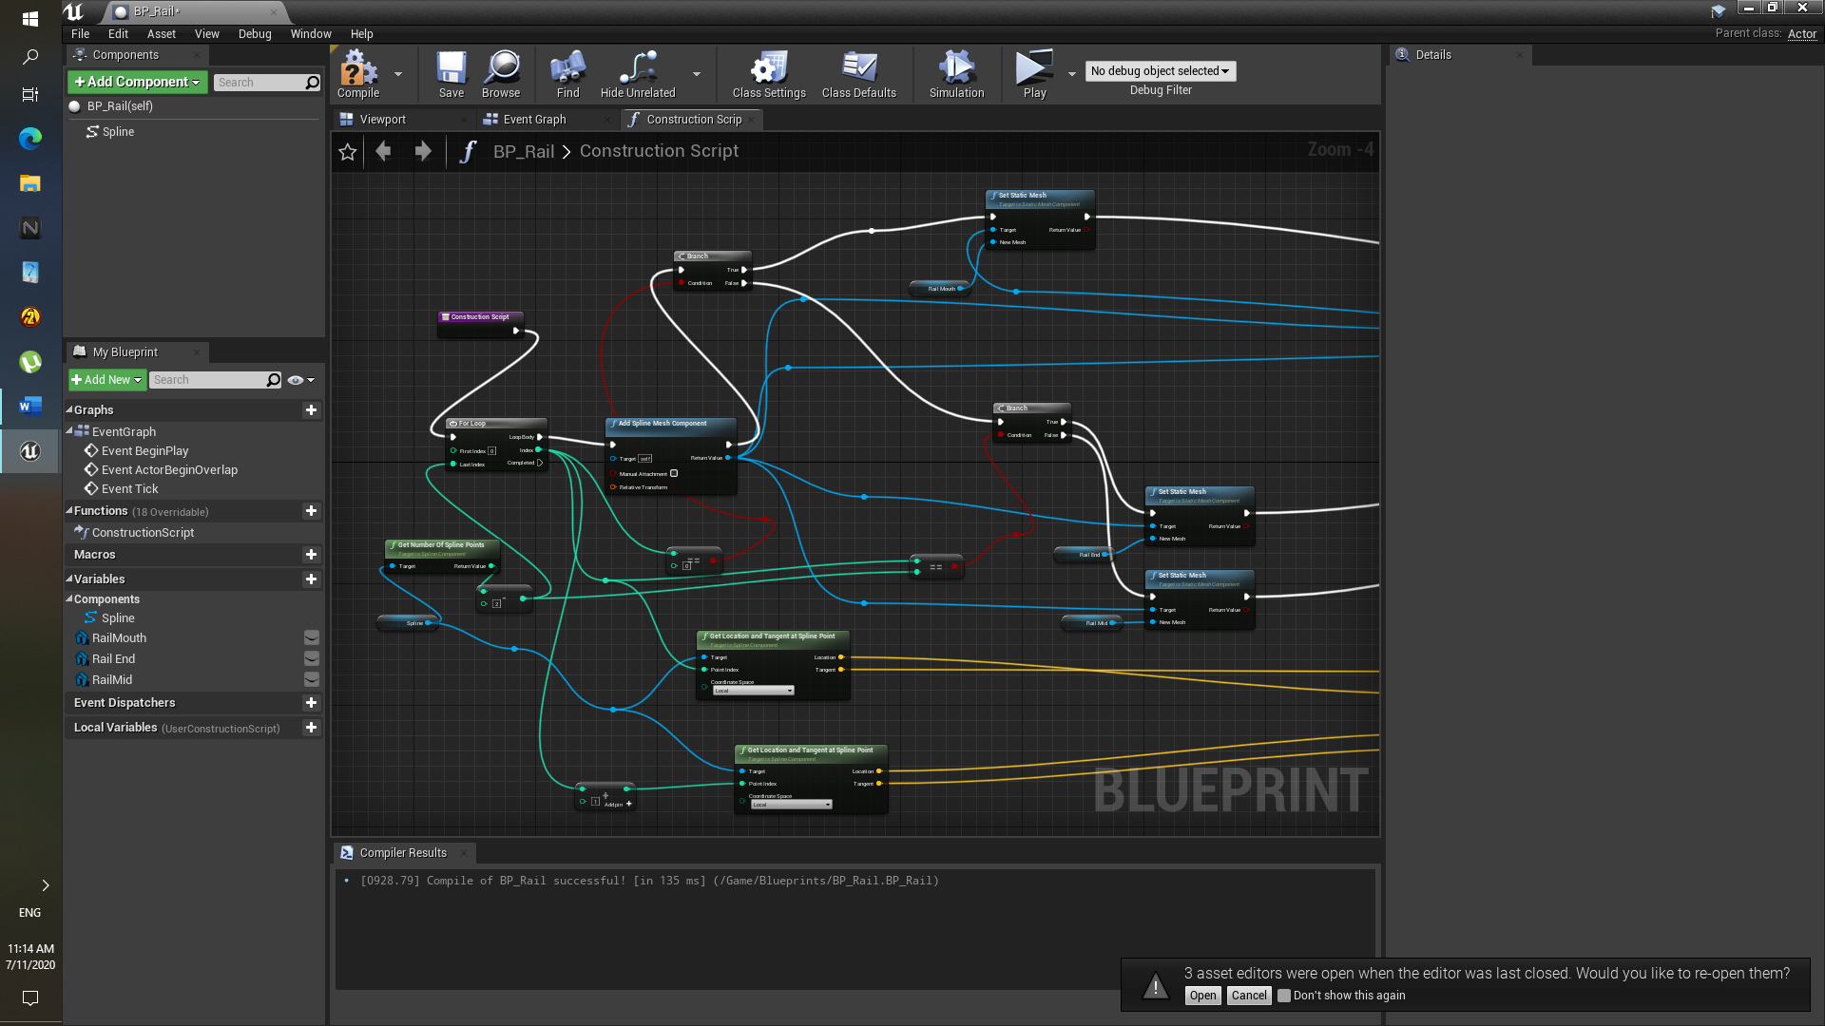

1. If the the points are second last two then the Rail mouth static mesh will be added if we the end spline point is extended.
2. As for the ‘Rail Mid ‘ static mesh added in between so no condition is there, directly in middle if we extend the spline point the, it will be added.
3. ‘Get spline location and tangent at point’ it is used to join the curved path to between two spline points via using the ‘Start and end’ scale.
4. As for the Ramp , SM_Rail , SM_RailMid, SM_RailMouth in the RAMP blueprint are replaced with the SM_RampNoTop , Ramp mid, Sm_PlasticRamp.
5. For the collision of the each static mesh of both the rail and mid, convex decompose is used at nearly max values.
6. Rail Look like this:

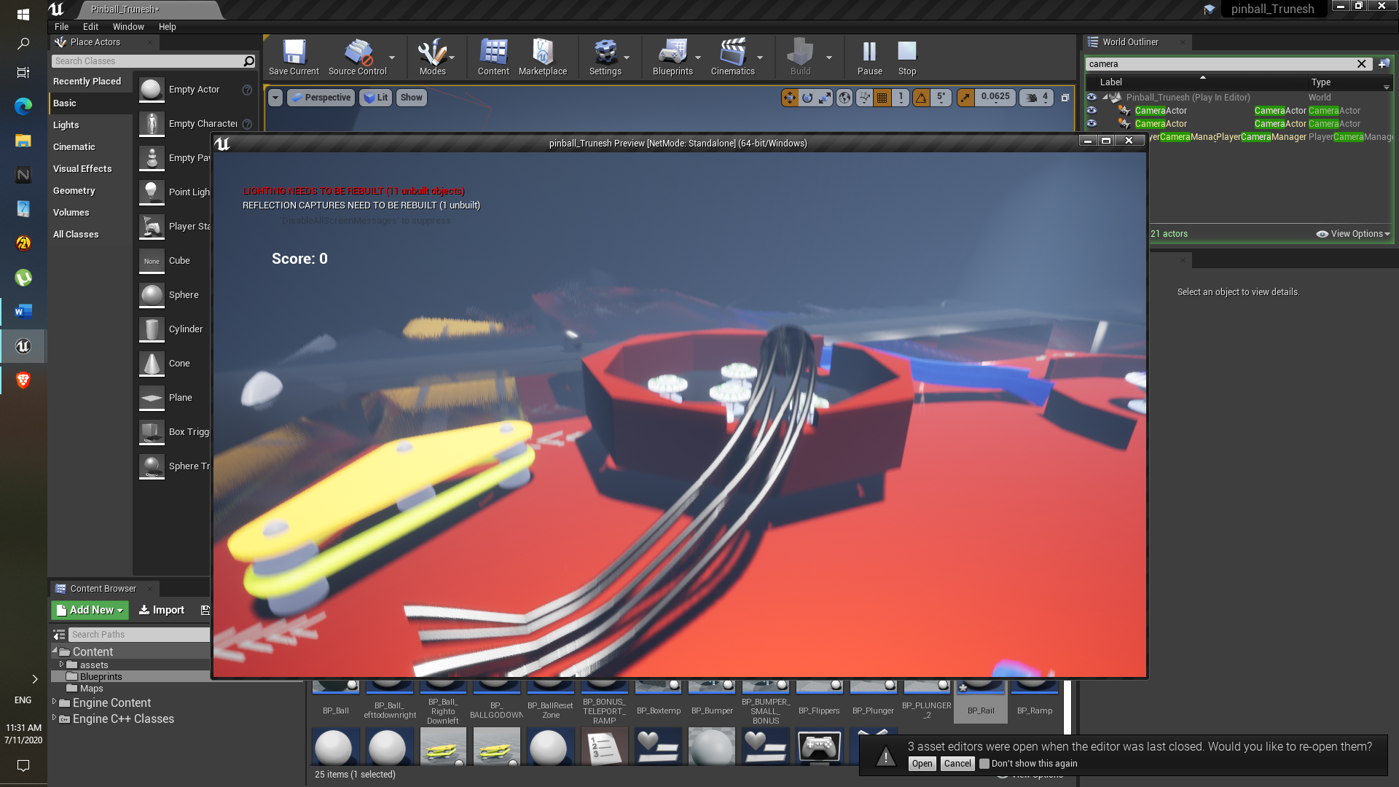

1. As for ramp:

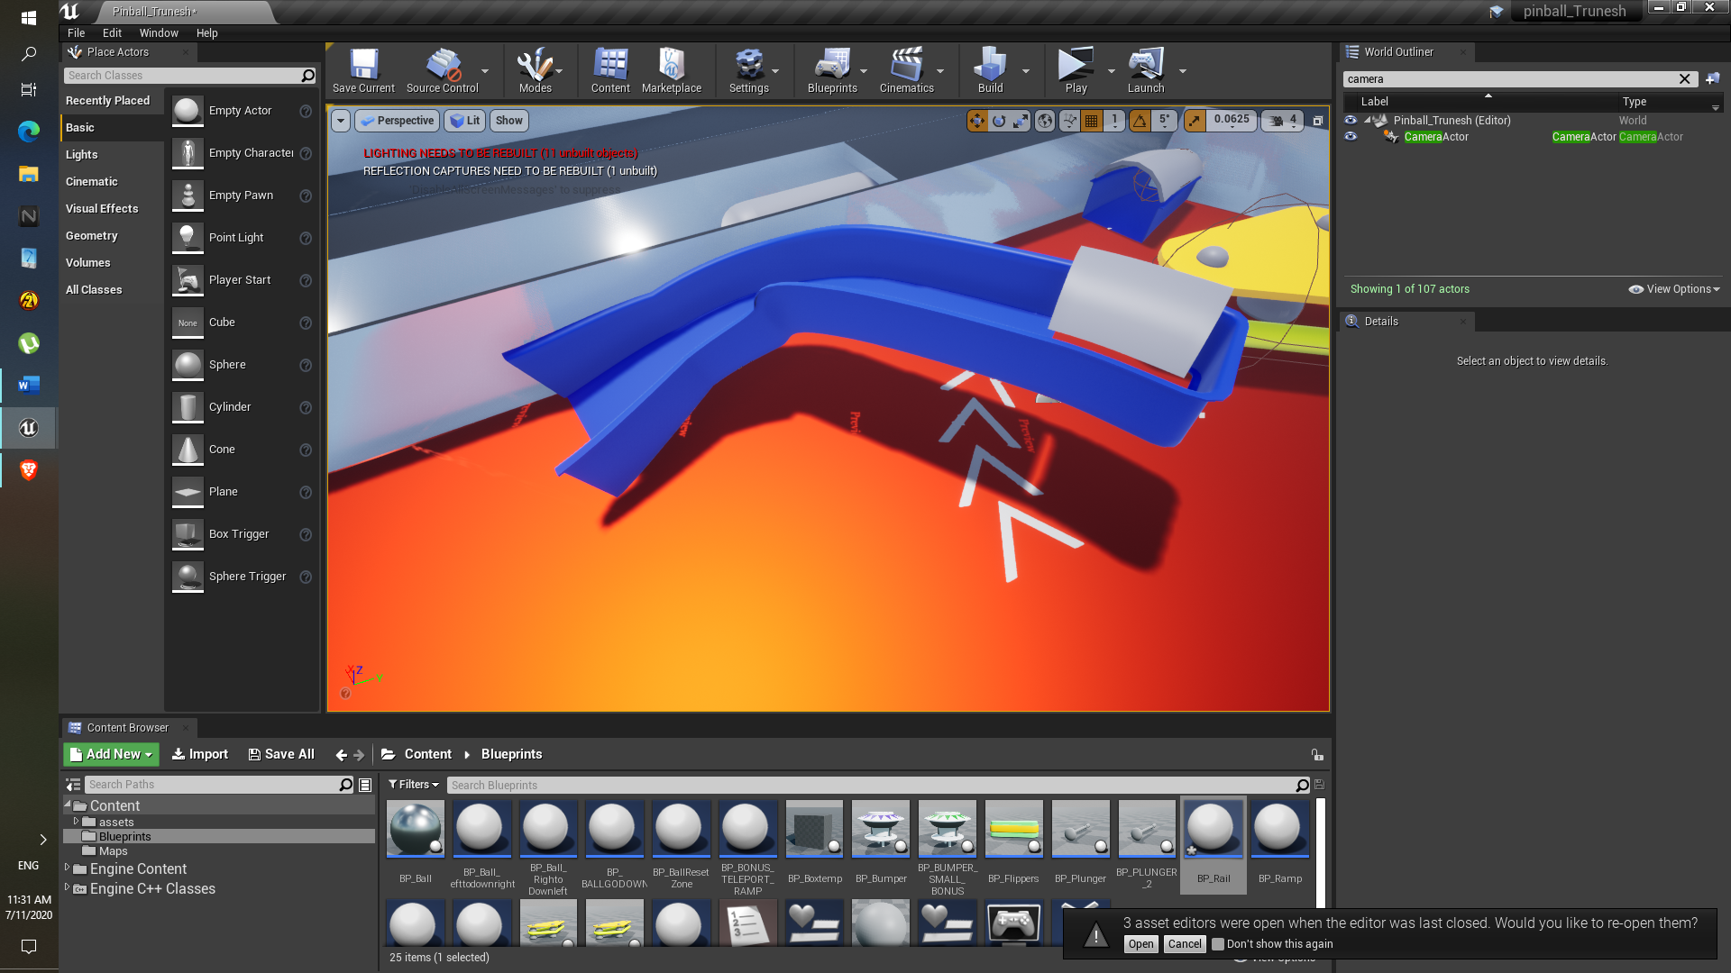

**Difficulty:**

Understanding the Spline blueprint as a whole initially was difficult.

Placing the Ramp was easy but the Rail, ball has to pass through rail so that It was quite difficult to make such curve using Rail.

Later using ‘set Start scale’ the X and Y scale is increased so that ball easily passed through it.

Assignment 6

* Set up the Decals using T_Decalpack_01 , Three decals as following: Straight Arrow, Curve Arrow, Pinball Board Corner Decal
* Add sounds to the flippers

**Description:**

Here we have to create the decals using the texture existing texture pack where multiple decals included in single texture pack. We have to extract decal one at a time via creating the decal.

**Objective:**

1. Learn to create decal via creating material.
2. Learn more about the materials as well as decals.

**Results:**

1. Here the Material is set to the differed decal so that It can be place on to of any static mesh.
2. Set to Translucent so that we can see through it partially.
3. Decal parameter , the ‘R’ is checked so that only that decal we can select out of three decals to create decal’ and the power and multiply the

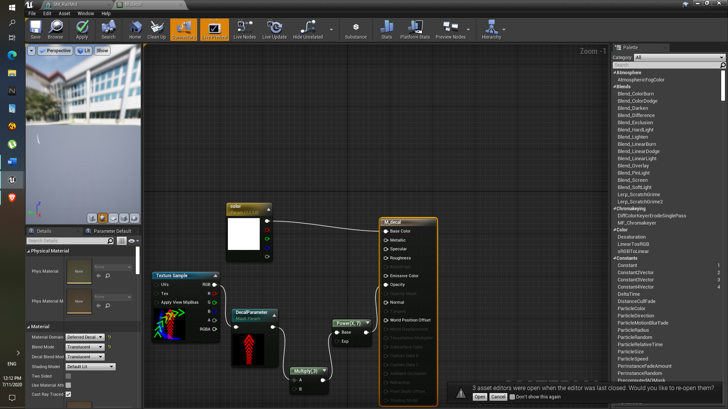

1. From the left side Place actor panel the decal is search and set it to the material decal which we created.
2. Now decal look like this:

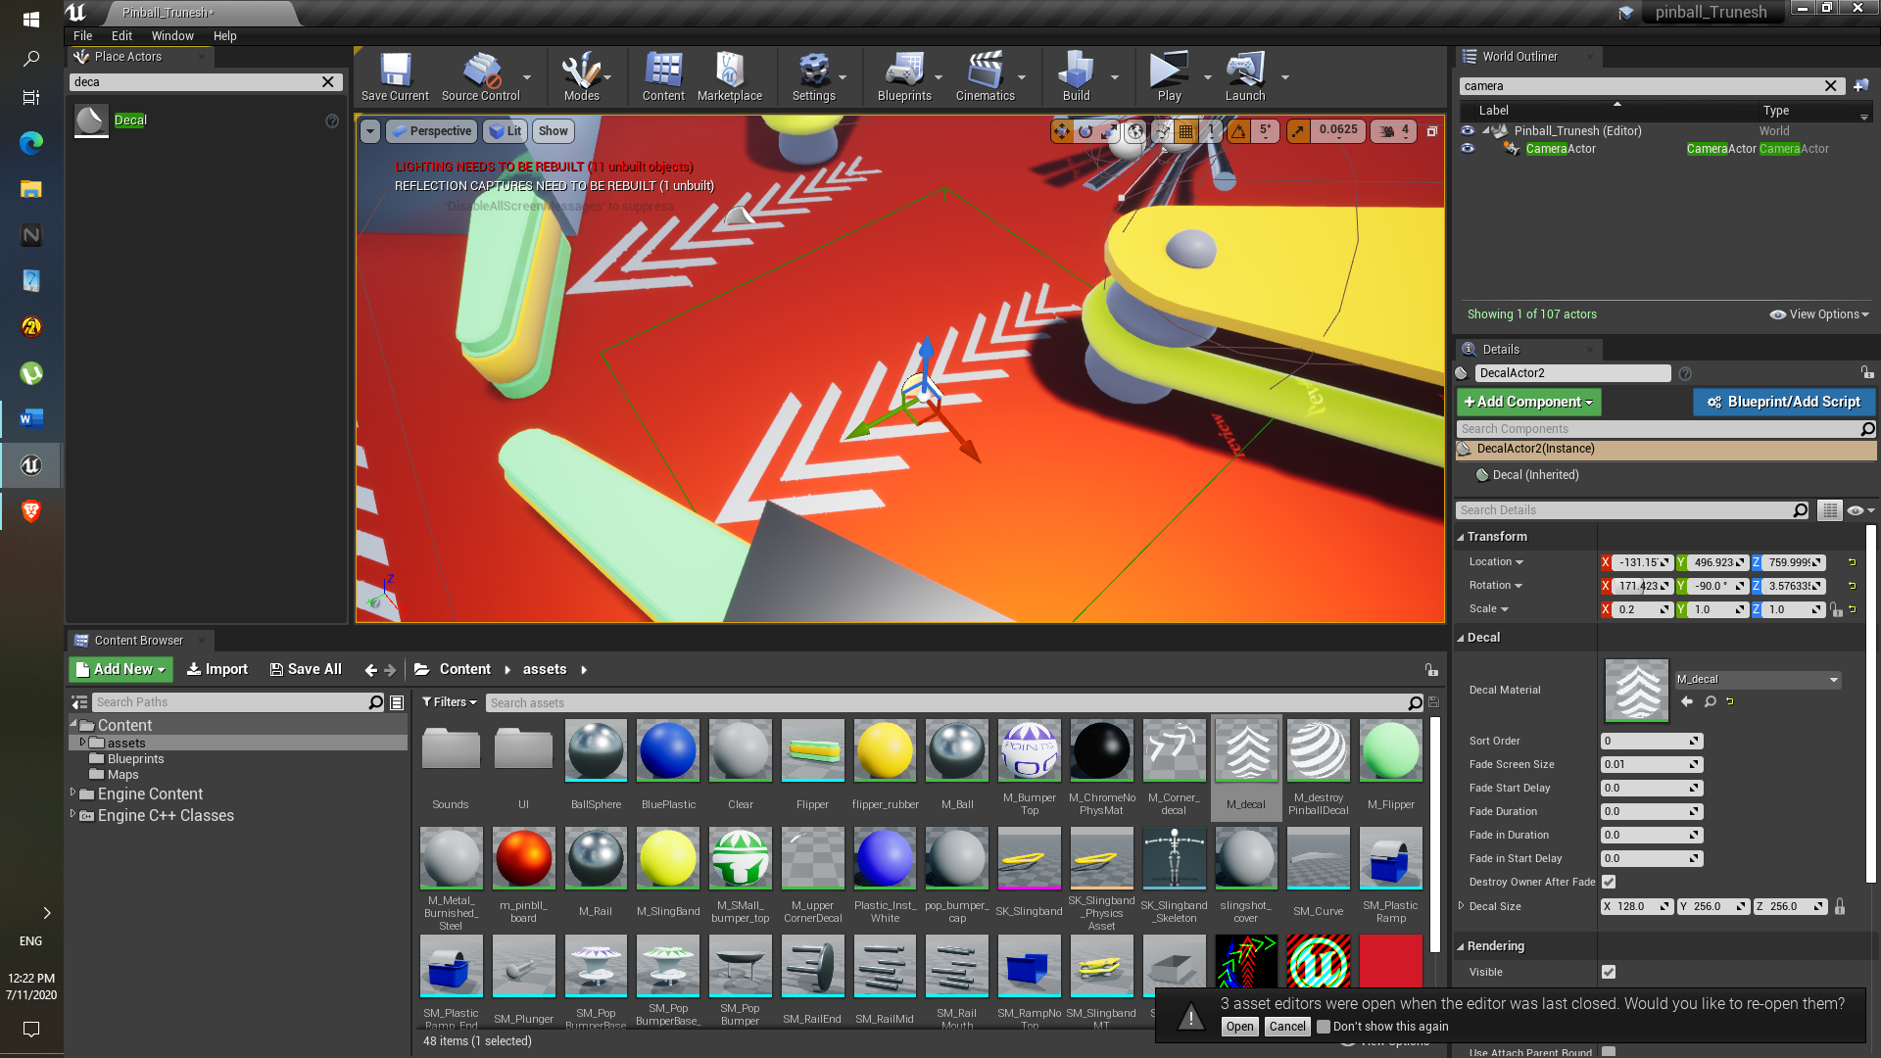

1. Other decals also made in the same way just selected different color while setting up the decal parameter such as ‘G’ green, ‘B’ blue.

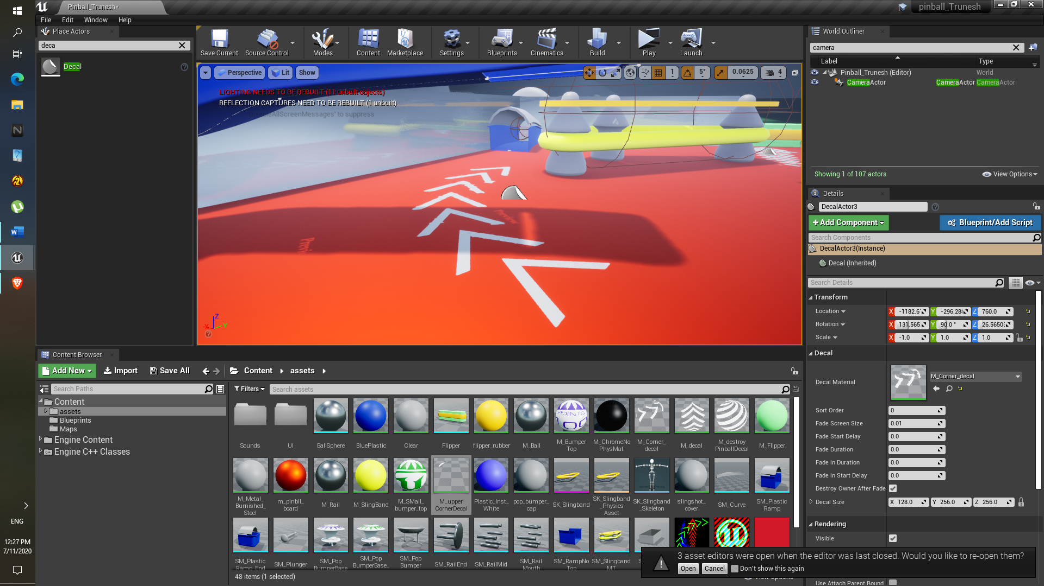

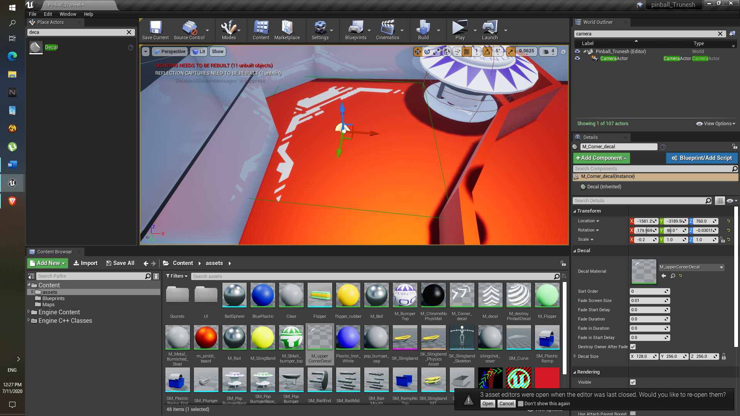

1. Also, to add sounds to the flippers it

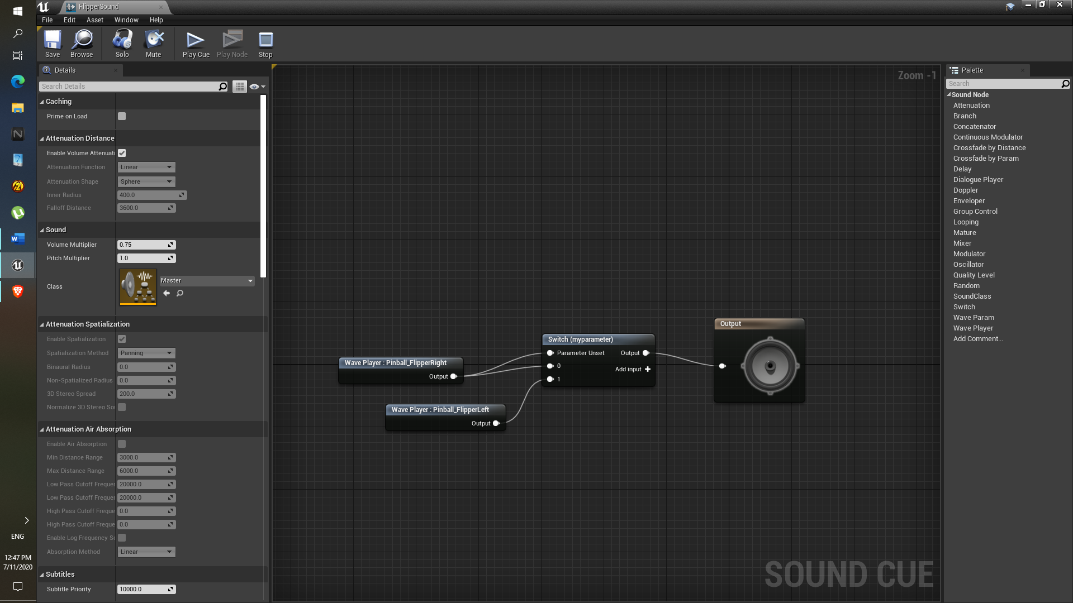

1. Following event graph is used.

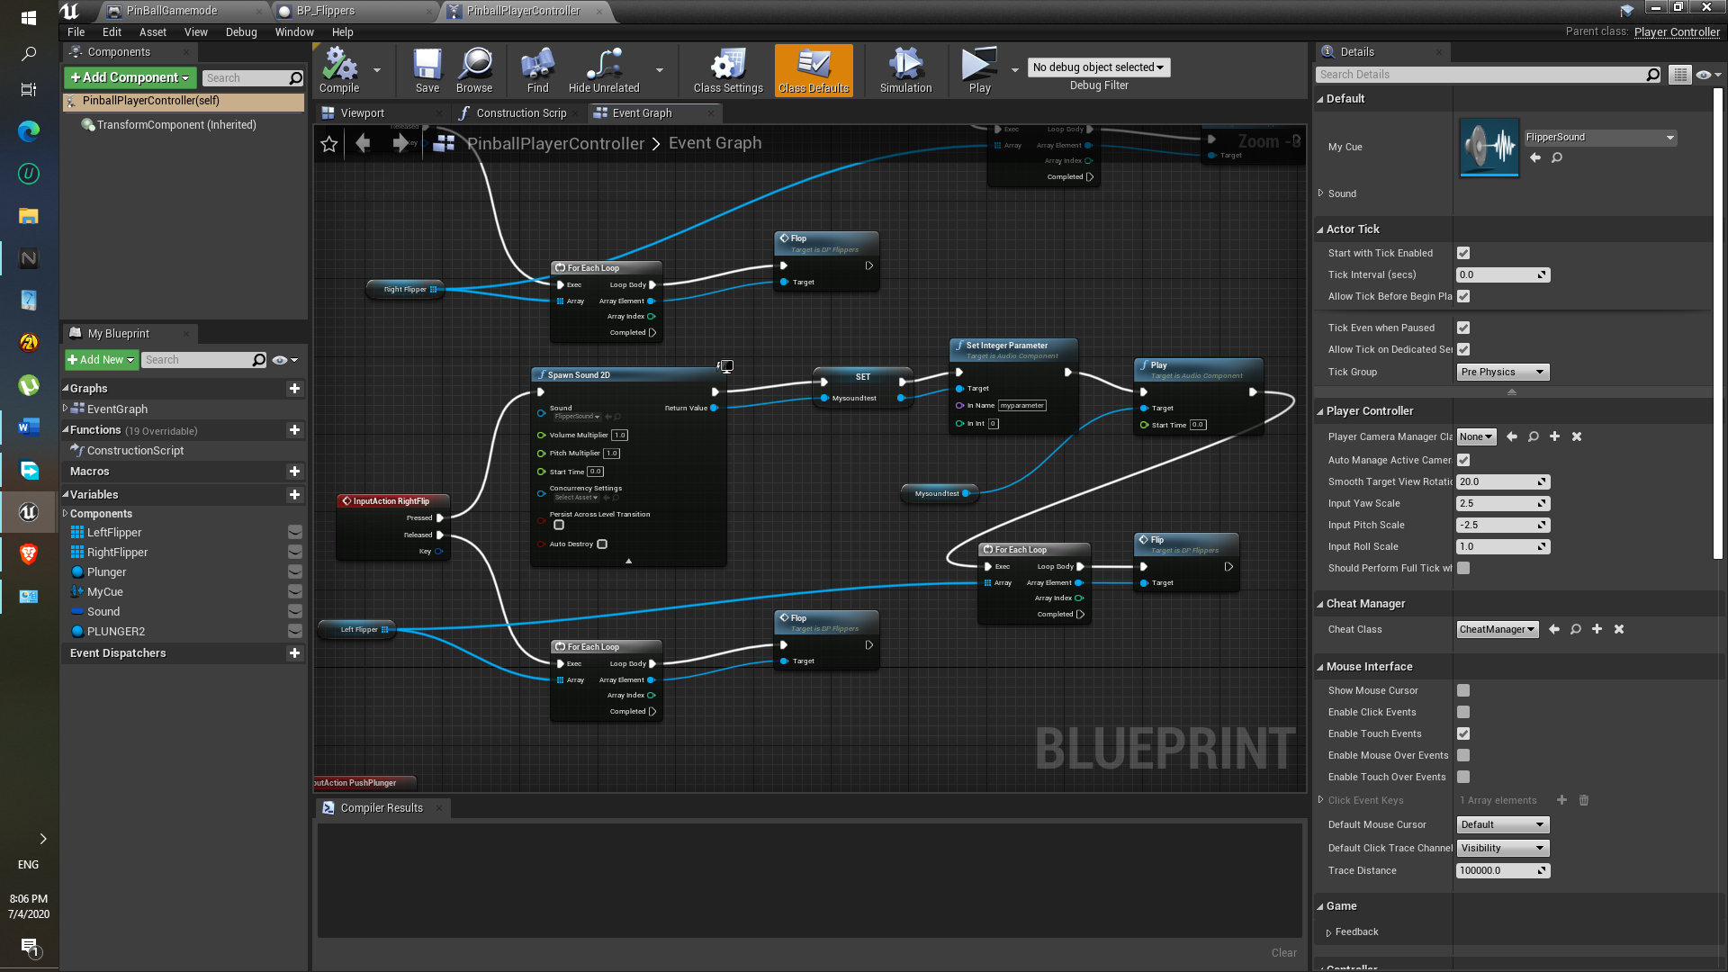

**Difficulty:**

Initially decal was invisible, so that’s why even after applying material directly on the pinball base.

Later I realized that we have to use the place actor panel and search for the decal and then apply the material.

Adding sound using two sound cues would have easy but I wanted to try add to add the sound to the flippers via using only one sound cue.

**Final Mini Project**

* Set up the Bonus region which should be in such position such as ball should pass through below , as well as Small bumpers should be included in the region and small hole to pass the ball.
* Make Central region, which includes the three Bumpers and have the path so that ball can pass through easily.
* Set up the Cannon which Shoots the ball in high speed.
* Make Ball teleport to the Ramp start position which goes towards to the bonus region.
* Set up two plungers which should work at the same time after hitting spacebar.
* Add sounds to the different Components, widgets , Blueprints Etc.

**Component: Bonus Region**

**Description:**

Here the ball has to compe through either two sides , from top ramp where the Teleport ball spawn occur if the ball goes to right bottom ramp of the pinball base and another rail is placed right side of this bonus region. The reason this is the bonus region because the small bumpers are placed in the region and their total is 5. This region is above the pinball base so that ball can pass through it.

**Approach:**

1. As shown in the lecture video, bonus region has to be in circular shape and having multiple sides, that’s why cylinders are used.
2. One Cylinder is used as base and another is subtractive as shown in picture below to add the same look.

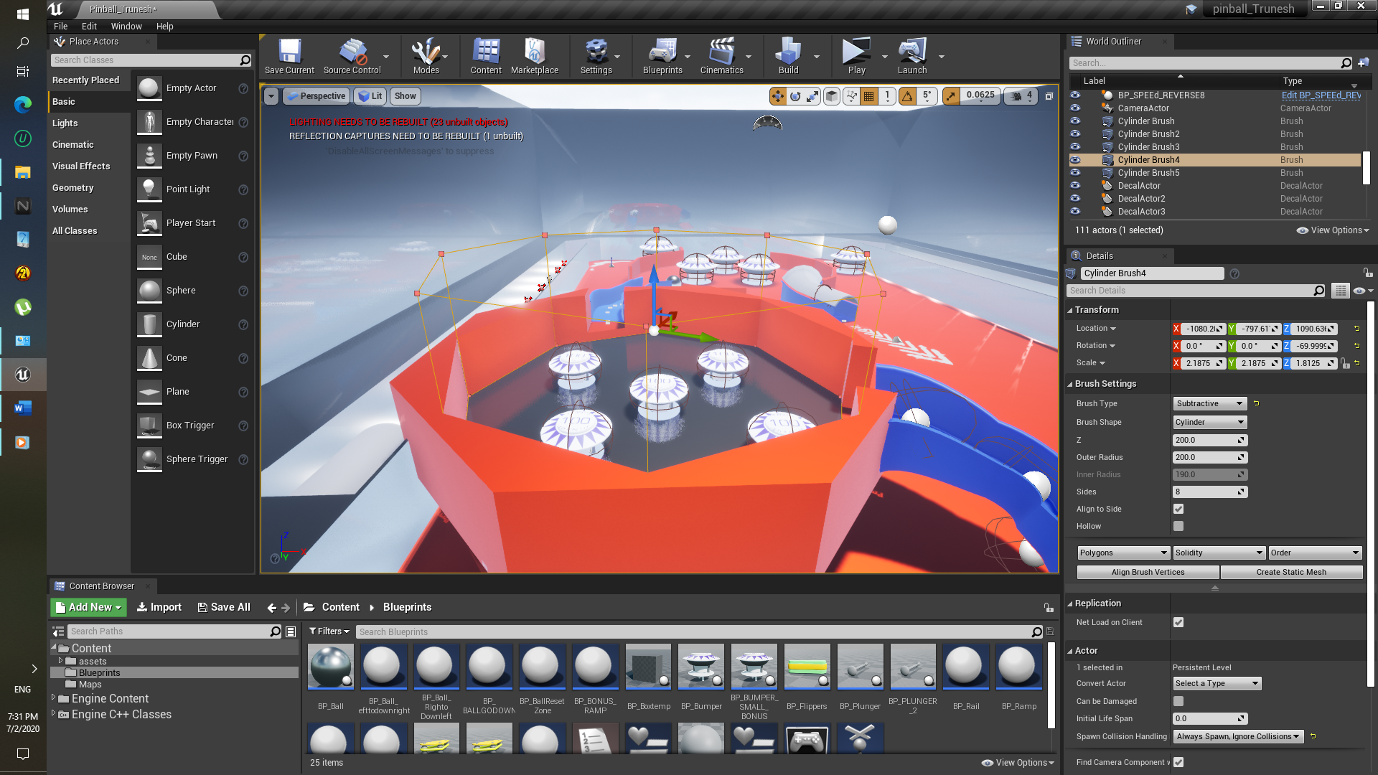

1. No. of sides for Subtractive and Additive for both cylinder Geometry is selected as 8.
2. Also, one more small Subtractive cylinder is placed where ball can go through it in the bottom Cylinder.
3. Right hand side of the bonus region, Rail is used for the ball to go in upward direction.

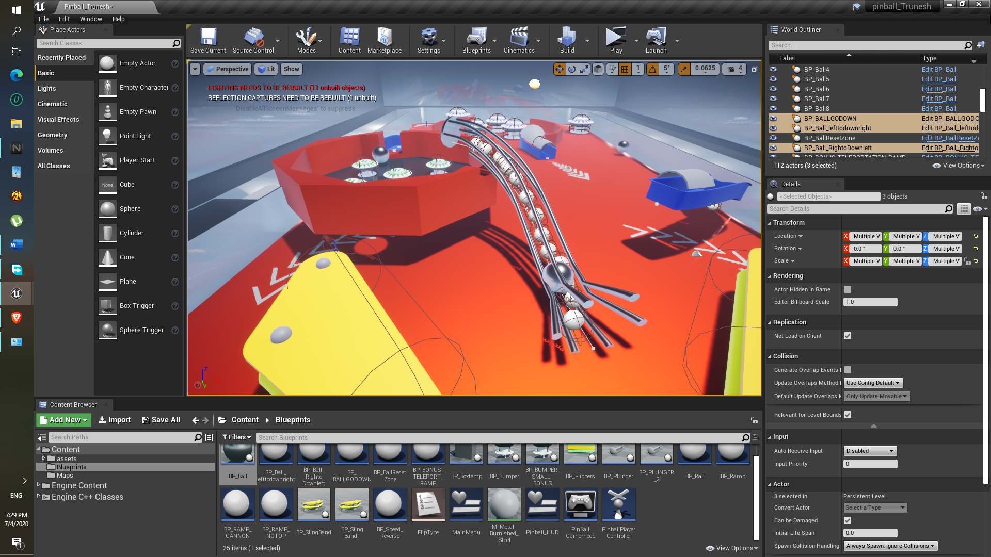

1. Also another blueprint class is used to make ball go in reverse direction named as “BP_Speed_Reverse” , as you can see it is placed inside the Rail.

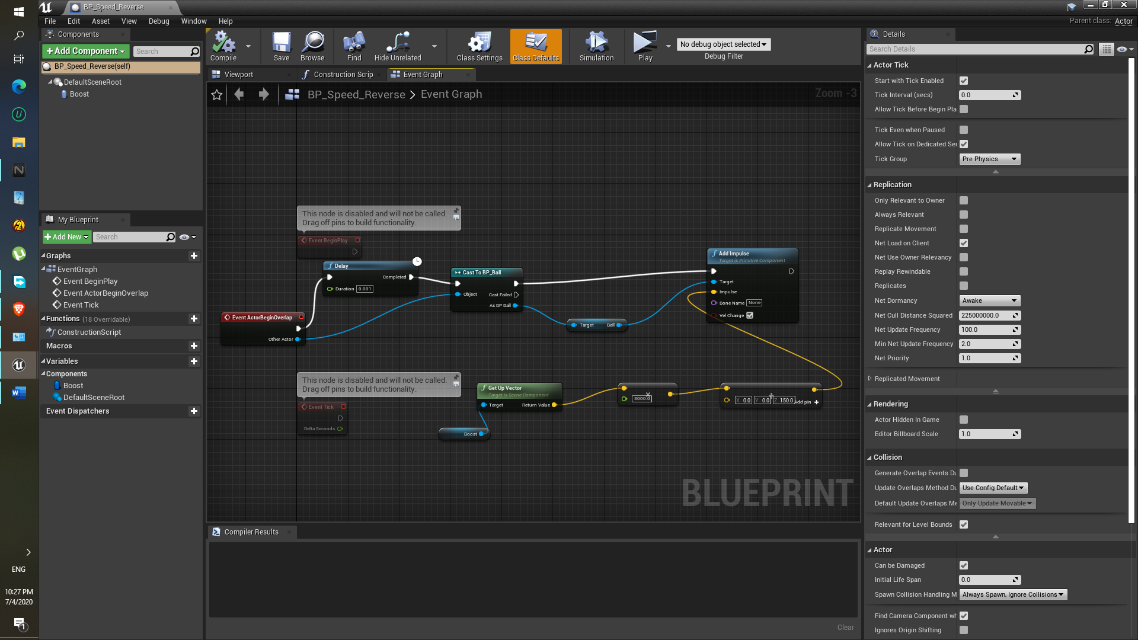

**Component: Bumper ( Small Bumpers inside the Bonus region)**

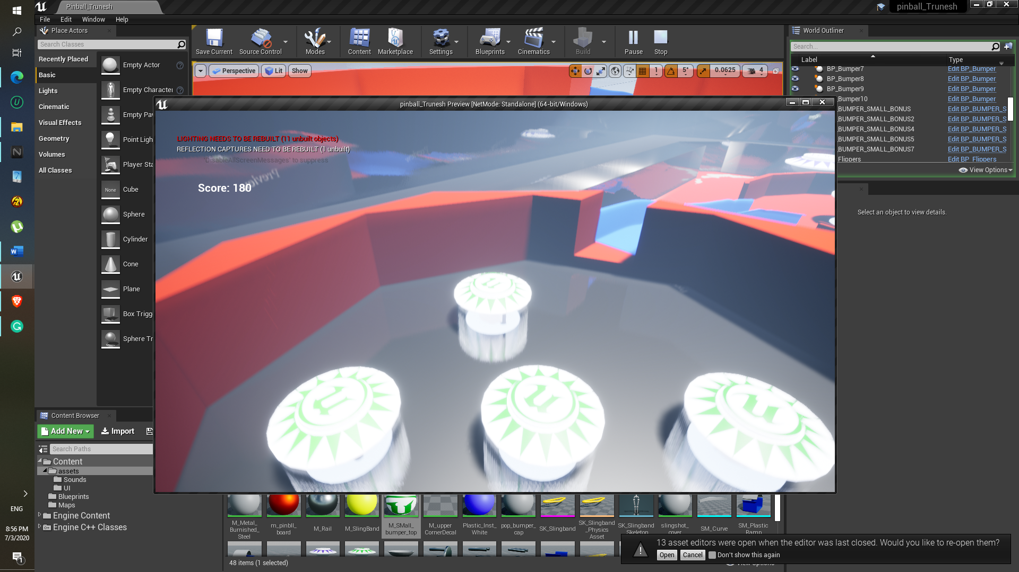

1. They are made using the Bumper(Large Bumper) reference.
2. In this graph the get actor location , that is bumper itself and the ball actor location is taken , so that the we should get the vector using ‘Get unit Direction(Vector)’ , like a perpendicular from the bumper position to the Ball.
3. Cast BP_Ball is used to check whether or not the ball is in the overlapping region.

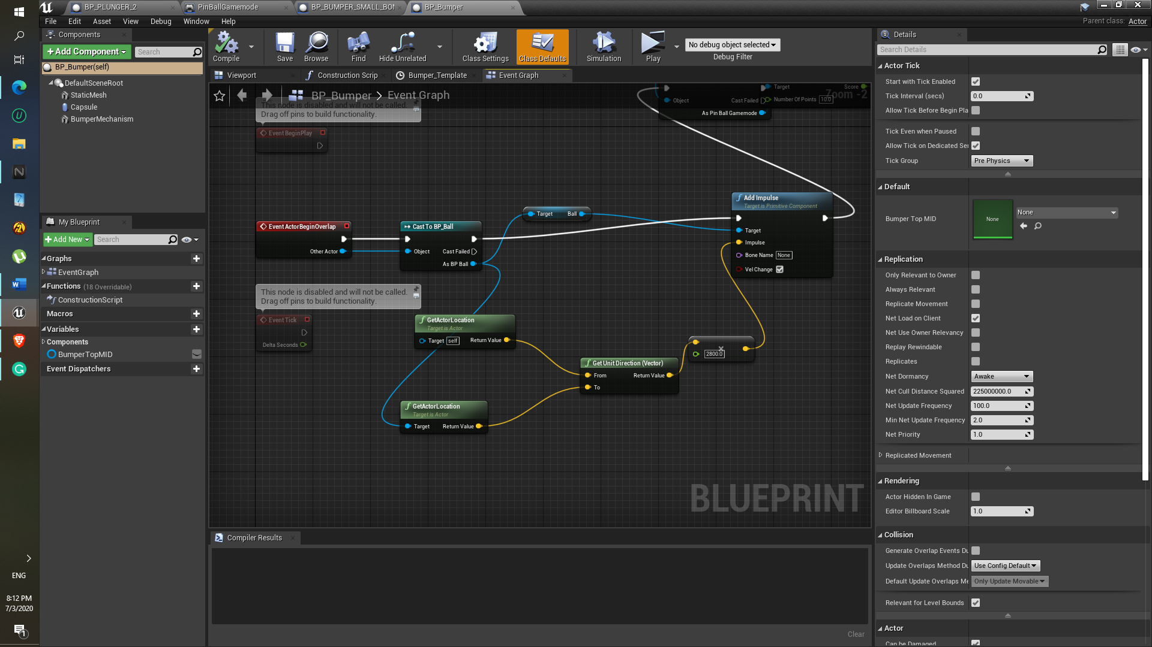

1. Also for the movement of the bumper mechanism again lerp is used, ‘set relative location is also work’ (Here I used ‘set relative location and rotation’ well if I don’t specify rotation it works same as set relative location)

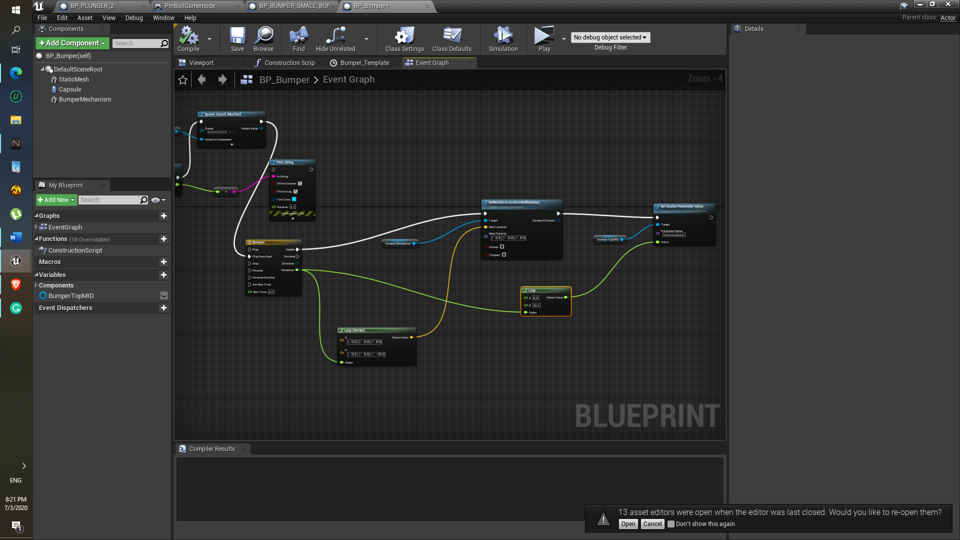

1. One change I had to made for the Bumper view port, because ball couldn’t touch its collision so I just increase it ‘collision overlap’

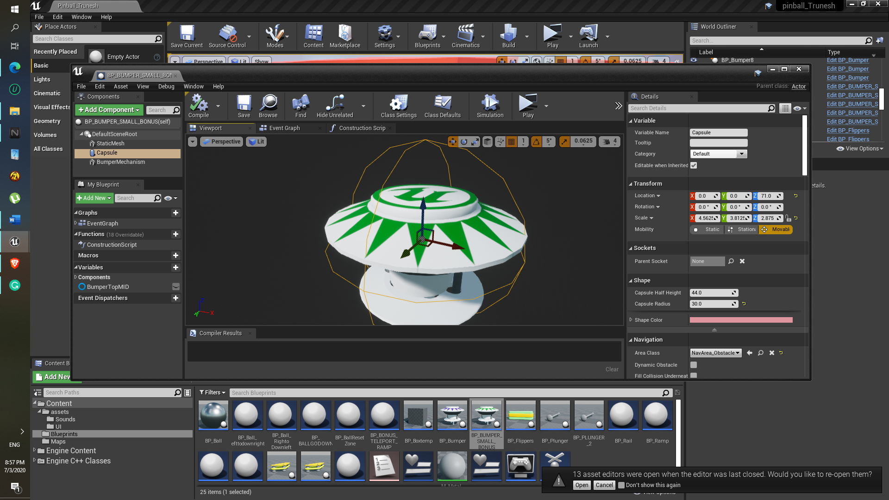

1. As for the material, texture was imported from the pinball asset.
2. Sounds are added using ‘Spawn Sound 2D’

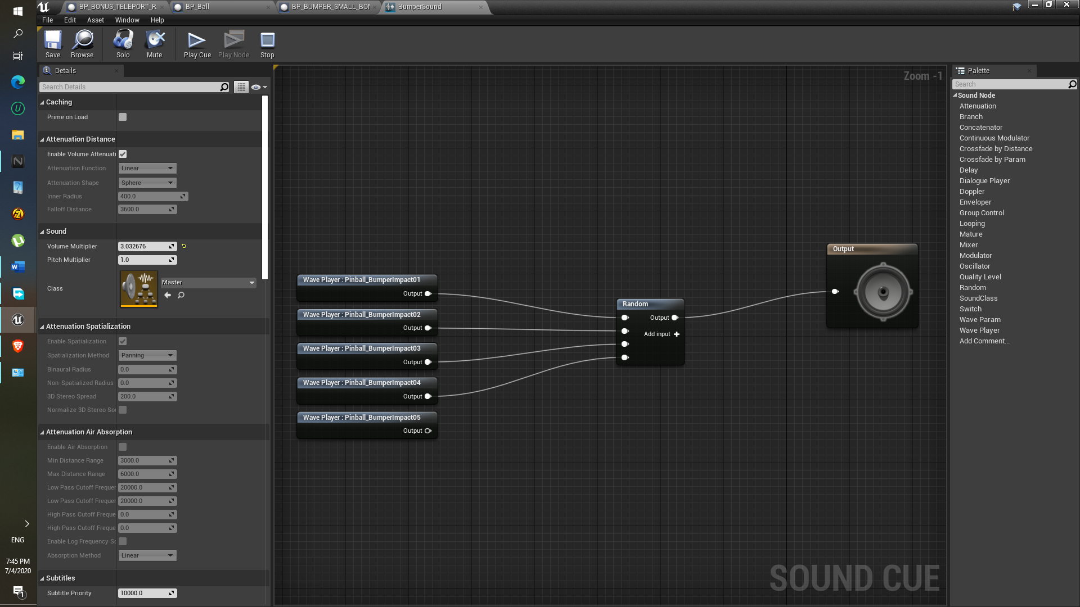

**Results:**

1. Successfully able to create the bonus region and able to place the hole in it , so that ball can pass through below it.

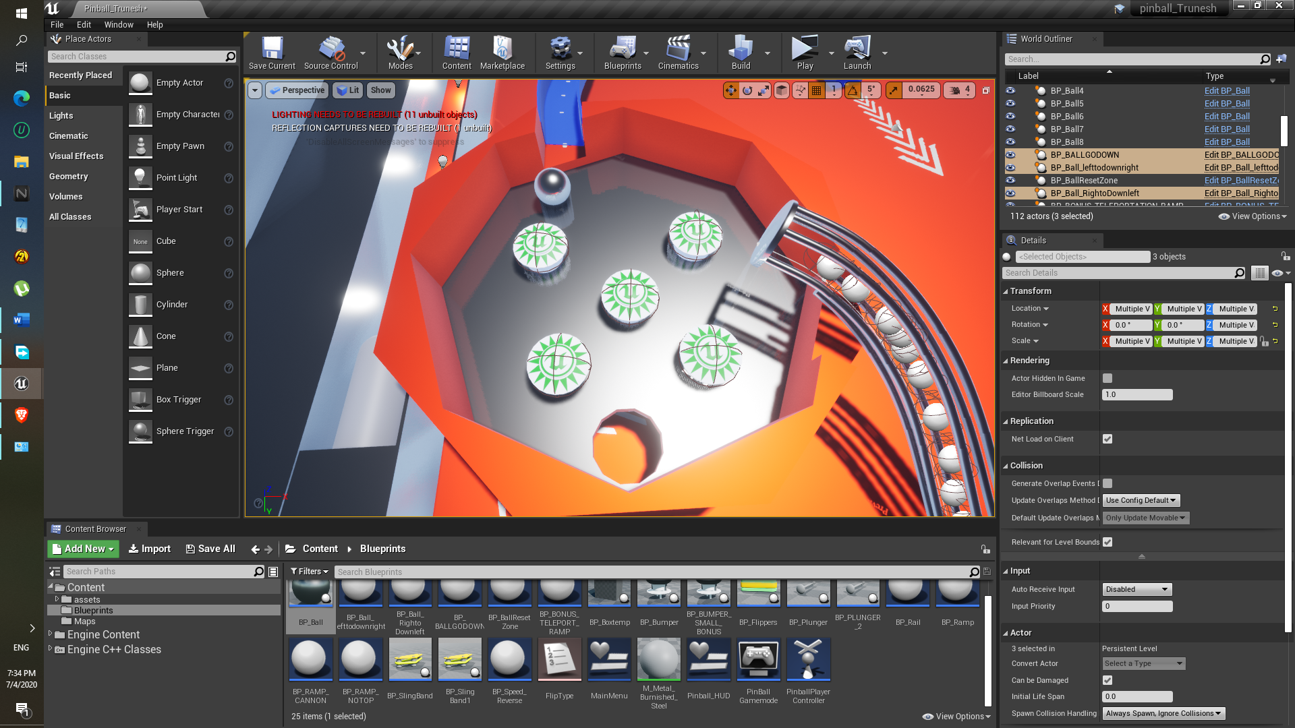

**Component: Central Region**

**Description:**

In this central region ball has to pass through and struck to the bumpers after entering it, so three bumpers should be there. On bottom right the cannon should be placed where ball speed should increase immediately after entered through it.

**Approach:**

1. This region is also made using the Two Cylinders geometry brush, i.e. one is additive which is attach to the surface and one is subtractive as shown in above image.
2. For that gap around the Cannon and the left side ramp, the Subtractive box geometry is used.

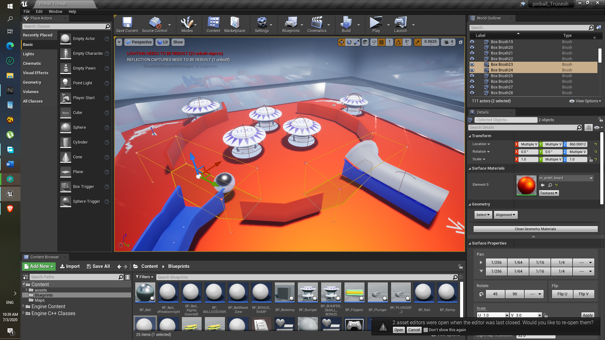

1. As for the Bumpers they are the same BP_Bumper, but the impulse reduced very slightly, so that ball should be on ground as shown in above image.
2. As for that top left bumper and right hand side of that bumper is the Geometry is box scale down to flat wall .

**Results:**

1. This how the Central region look like, the three Bumpers are placed and the Cannon is placed on the bottom right of the Central Region

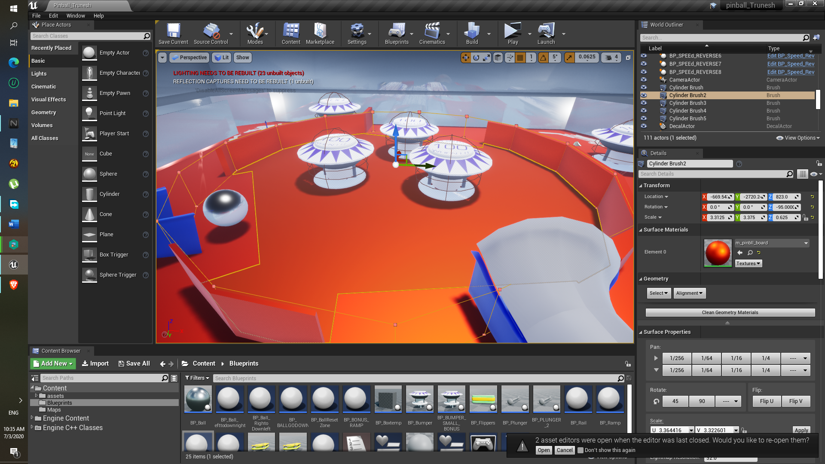

**Difficulty:**

None

**Component: Cannon**

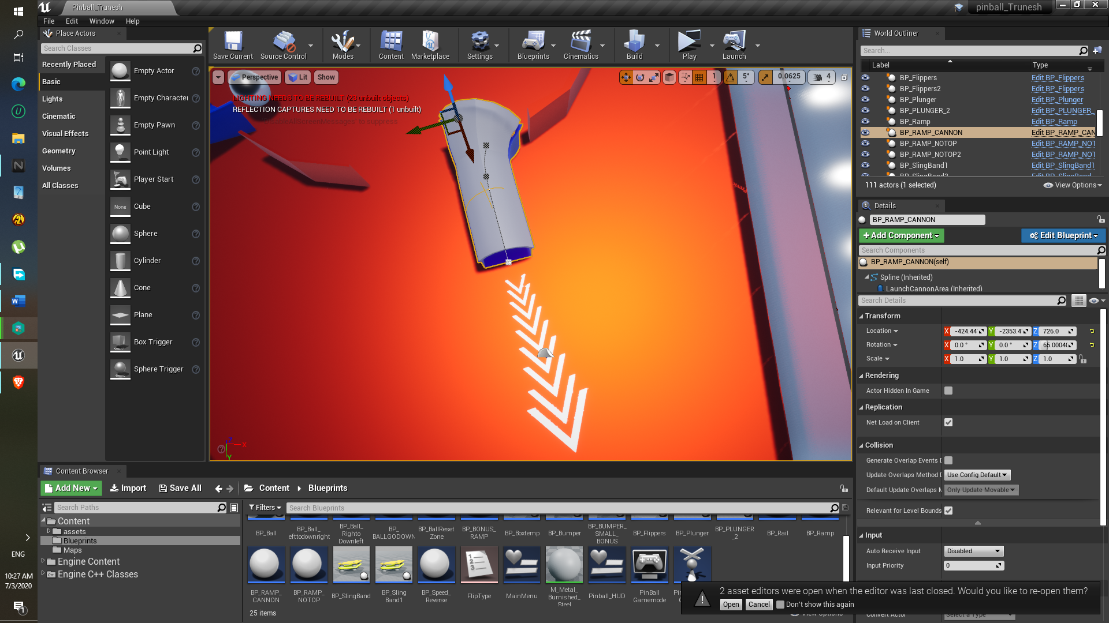

**Approach:**

1. This is also done using the rail blueprint.
2. Added the Collision at the end part of the ramp so that if ball pass through that collision, the quick boost will be generated.
3. In the collision part, the following components are added, here get right vector so that ball can go to that particular direction.
4. That Decal is just copied as it is from the existing once that I created.

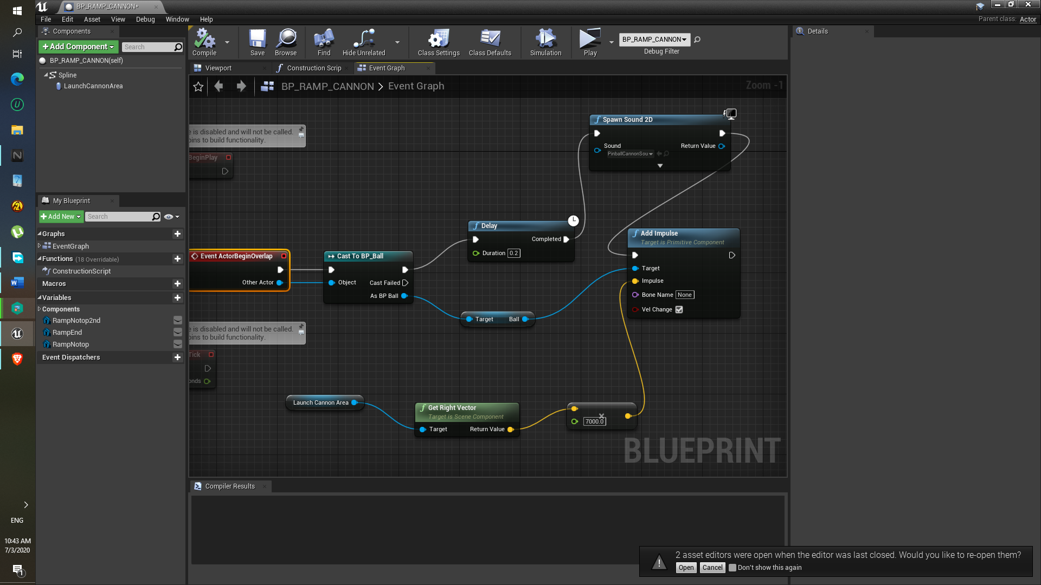

**Difficulty:**

Having trouble with creating ramp or rail of my own, I did not understand properly, here I thing should have created the Ramp using only the End part mesh (EX. RAMP_END ) and only two points, but in the blueprint I used the same Rail Blueprint , it’s the same Rail blueprint.

**Component: Bonus Spawn Teleportation**

**Approach:**

1. This region is also made using the ramp blueprint class.
2. In this BP_RAMP_TELEPORT_BONUS blueprint class, the collision overlap is added at the end part, and as shown in the top most figure , the other spline points are deleted, as same with the cannon component.
3. As part of spawn location, it is placed manually, yeah by dragging it.
4. This event graph is made using via help of the plunger blueprint.
5. These components help to spawn the ball at “Spawn Bonus” position

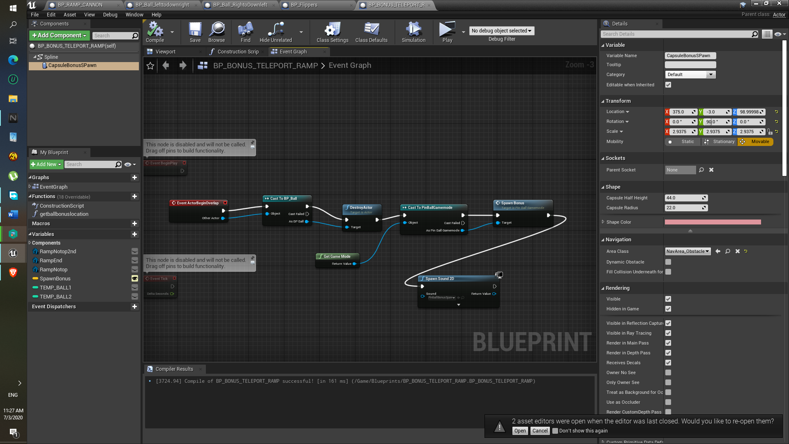

**Results:**

1. So if ball pass get inside the below ramp it teleport is and spawn in the 2nd picture below this ramp.

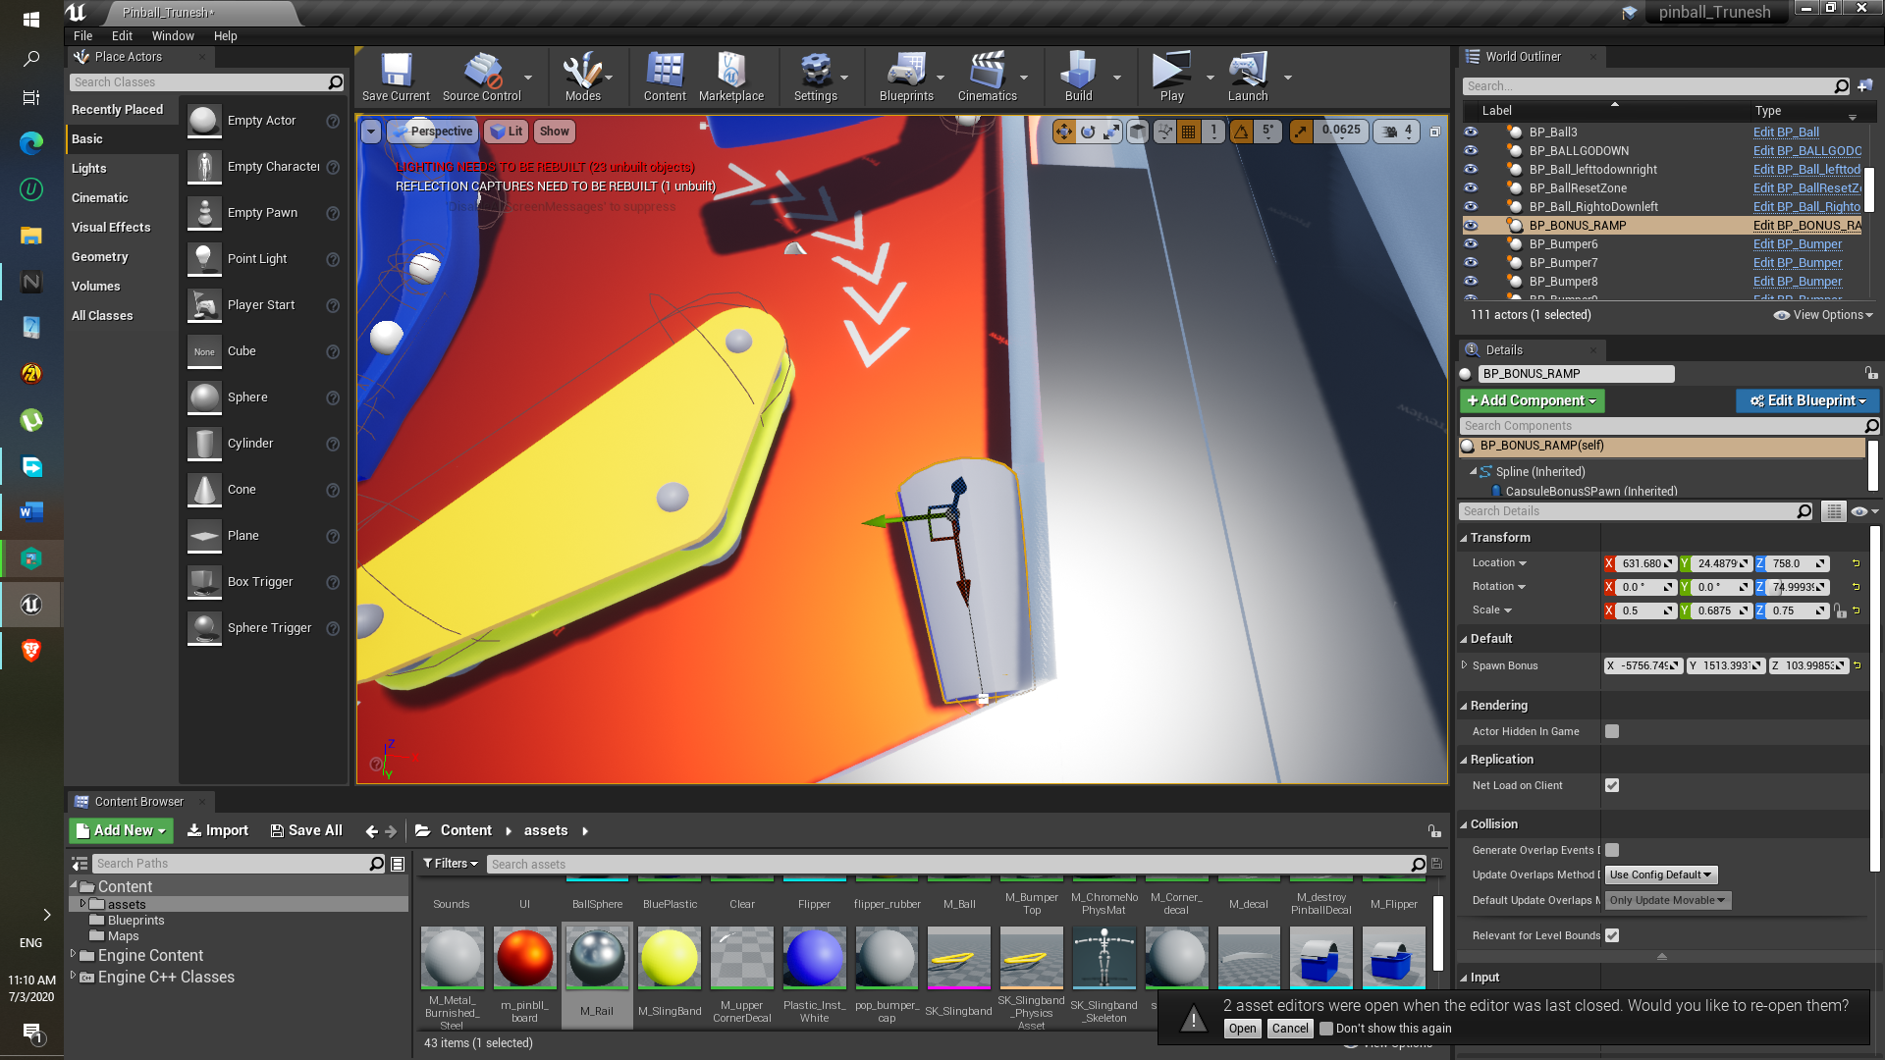

1. This is where ball get spawn.

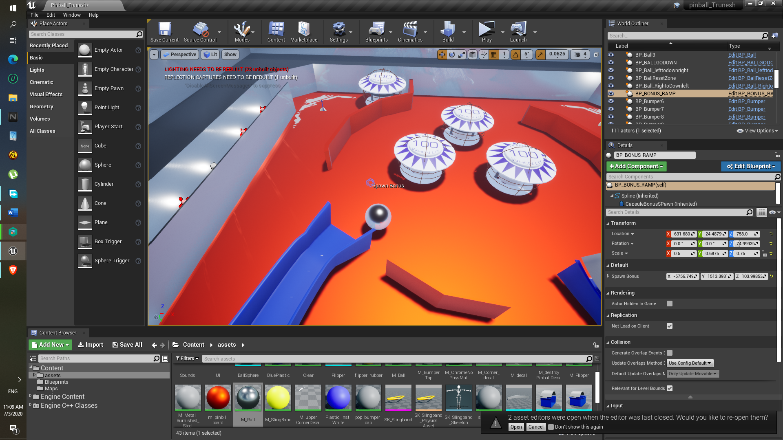

**Difficulty:**

Well I actually tried that get ball location of my own, like using some component “get world location” or something I can’t recall, but I unable to get the “spawn bonus “( Instance 3d widget ) location, so in the end I just used the BP_Plunger class Function “get ball location” help to get the “spawn Bonus” 3d widget location and get Actor transform.

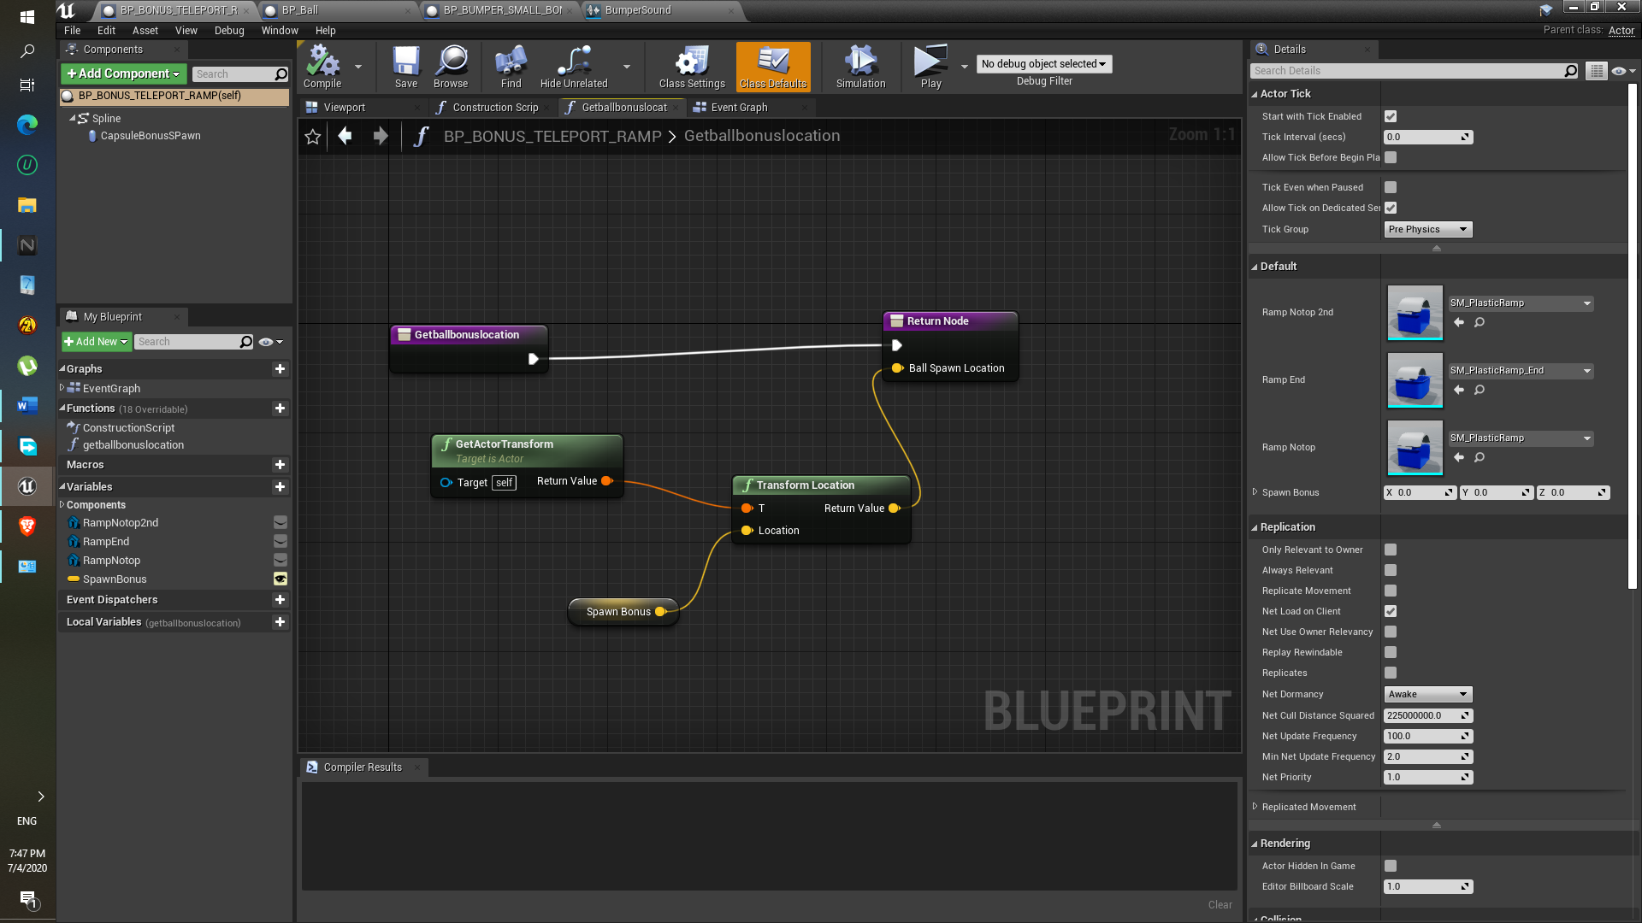

**Component: Plunger**

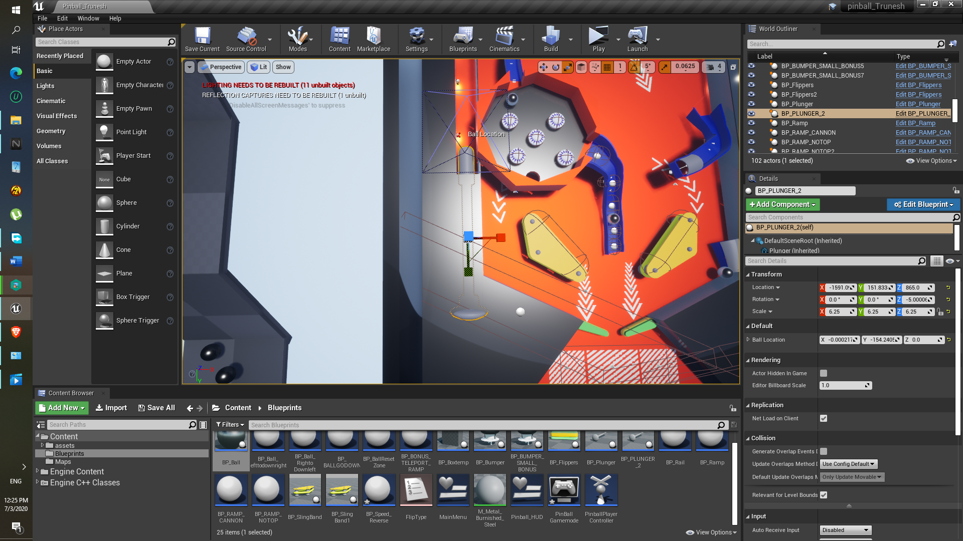

**Approach:**

1. Plunger should be move backwards after pressing and hold Spacebar.
2. That’s why the timeline is used.

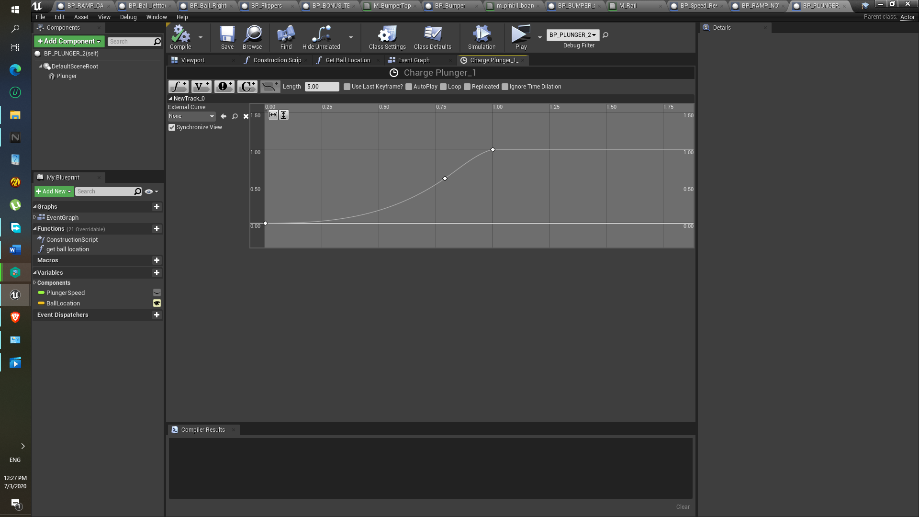

1. In project settings and in “input” is specified using action mapping feature, space is assigned for the plunger movement.

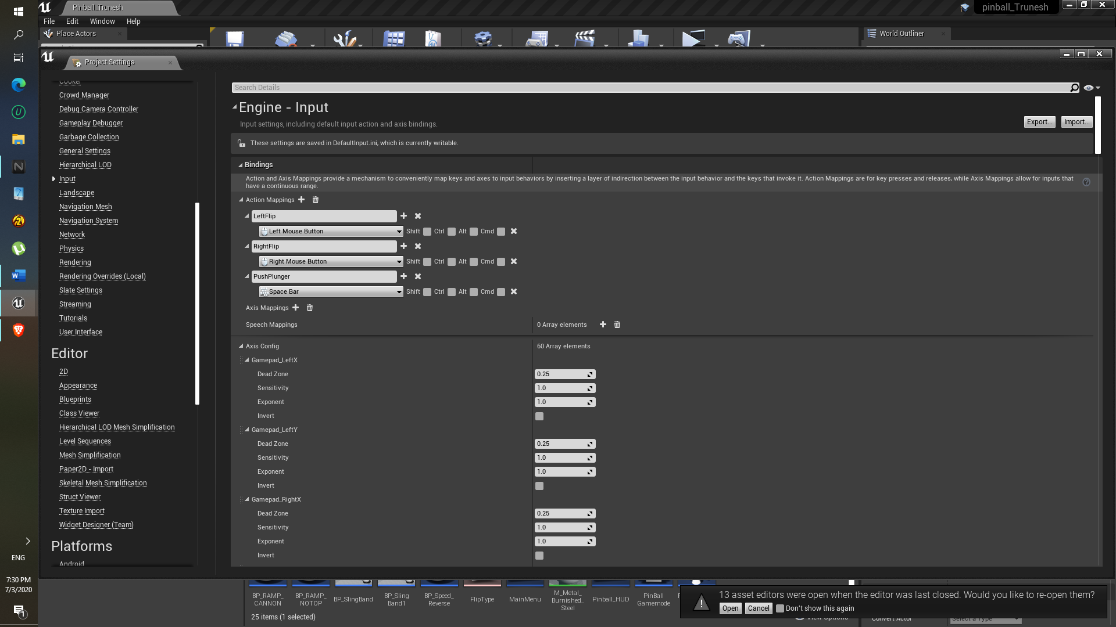

1. In event graph the lerp is used so that, the plunger will move back from its original position to the specified position at given above timeline.



1. As soon as spacebar is released the move component will move plunger to its original position.
2. Get ball location function is used to spawn the ball.
3. In pinball game mode the Spawn function is created, in that function the ‘Spawn actor from class’ is used to spawn the actor at particular transform/ position, that component uses ‘Get ball location’.



1. To end the game, I simply added to Booleans and check them after getting ball count upto 3. For both plunger that means total 6 balls.



9)Added sounds to the when plunger is charge, that is when Spacebar is hold and when it is released.



**Result:**

As shown in the picture the ball is spawn on the top of the plunger.

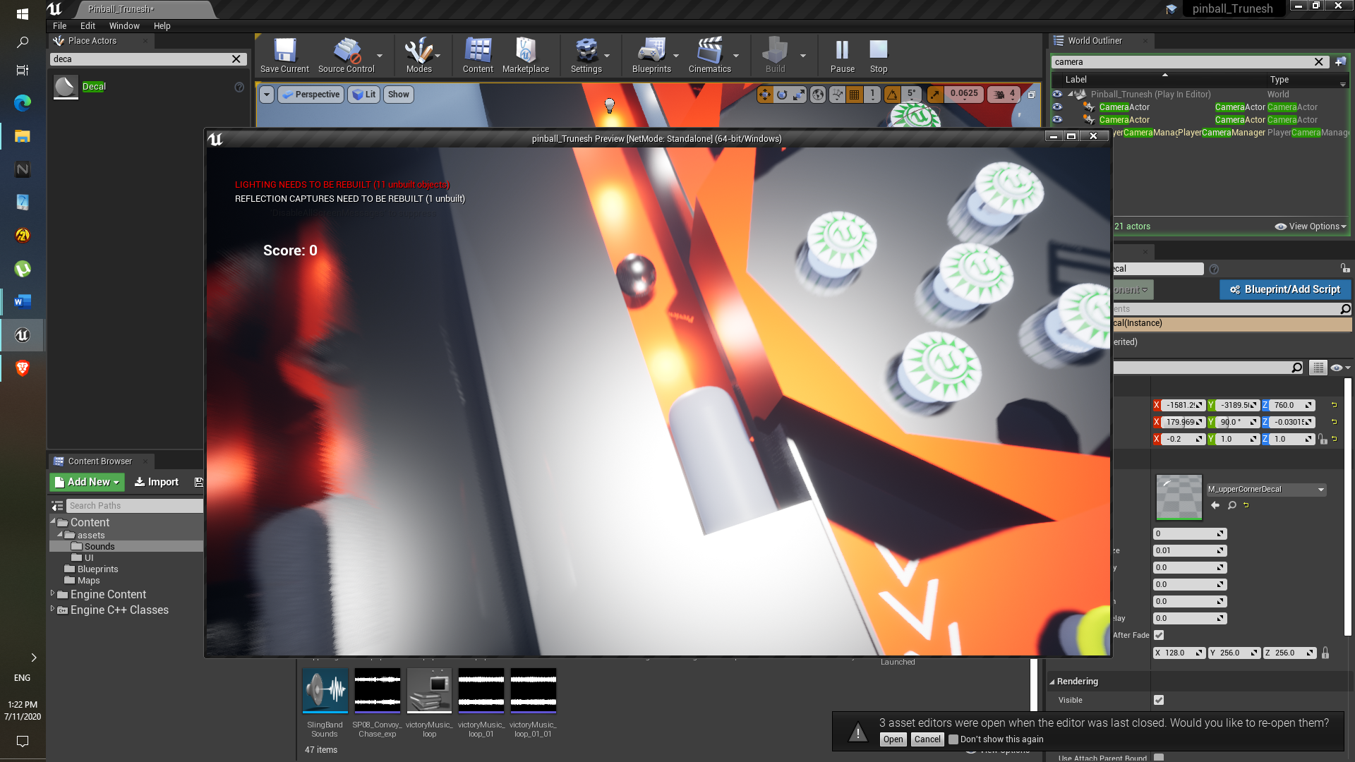

**Difficulty:**

Plunger was flying off for some reason, later I realized that we have to disable the Simulate physics. So, it won’t fly off.

**Component: Side Ramp**

**Description:**

This ramp should be created to not let the ball directly into the Teleport Ramp which is ahead of this Side ramp.

**Approach:**

1. This is also develop using the Rail blueprint.
2. Static mesh Rail mid, Rail End, Rail mouth are replace with mouth_plastic ramp, Notop_ramp, Ramp_End static mesh

**Result:**

1. Here the additional 6 spline points are required to create the Side ramp.
2. Via adding convex decompose their static mesh collision is added.
3. This is how Ramp look like:

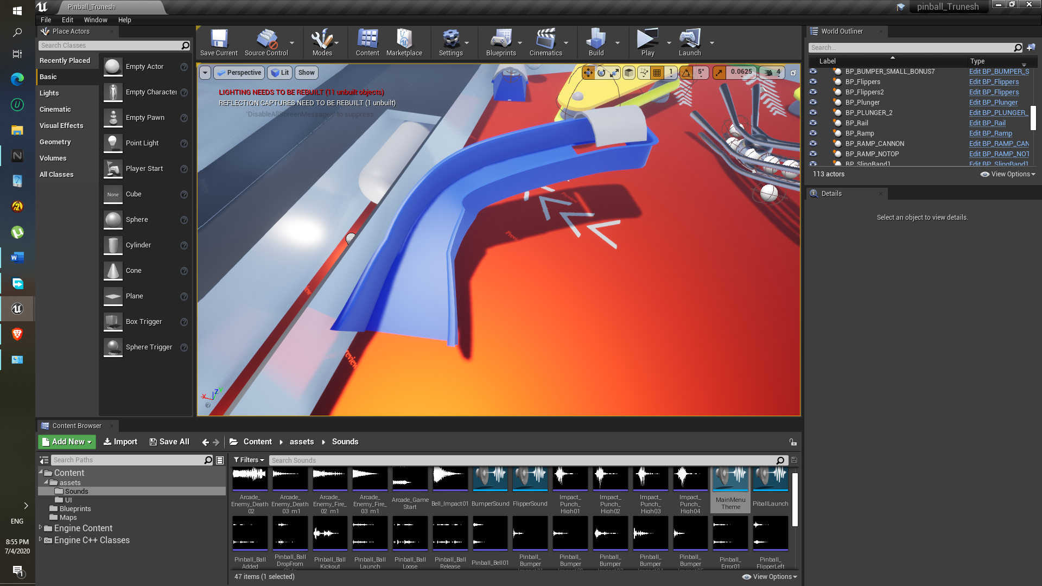

**Difficulty:**

None

**Component: Table frame**

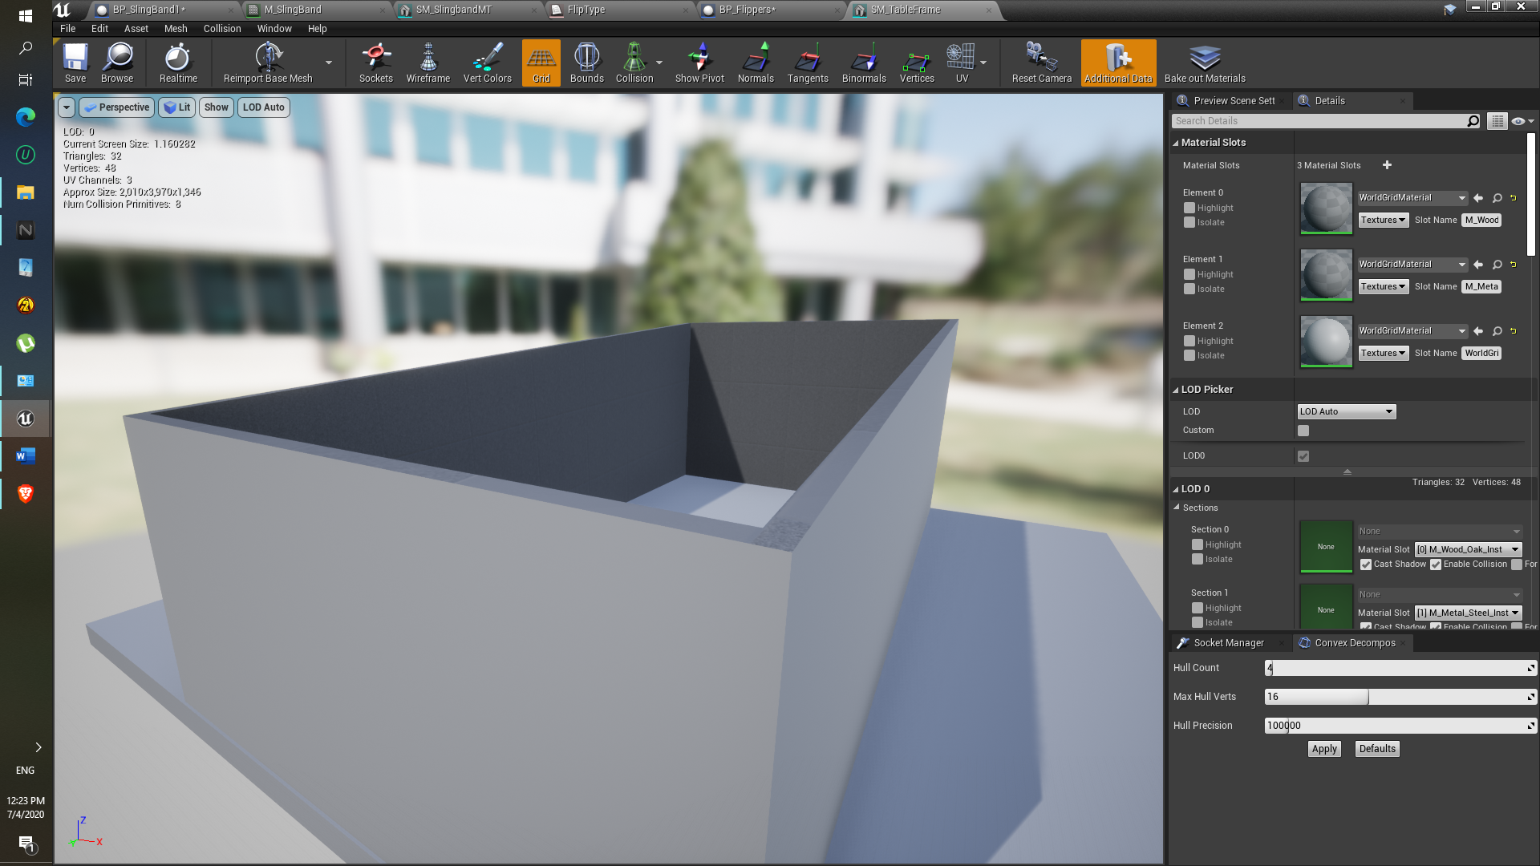

**Description:**

This table frame will be act as a border wall of pinball game , this frame will be there to create more dynamic look.

**Approach:**

1. Static mesh directly imported from the pinball assets.
2. Added collision in the static mesh editing using convex decompose

**Results:**

1. Table frame scale adjust according to the pinball base and place properly

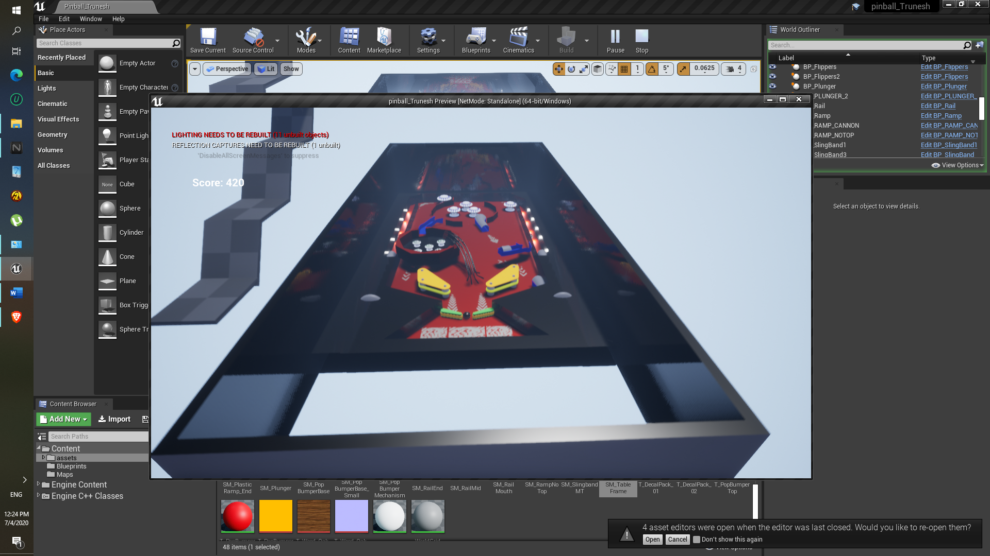

**Difficulty:**

None

**Component: Plunger Ball Path, Plunger locations and Lights etc.**

**Approach:**

1. Ball has to pass through that region, so the Subtractive geometry box is used.
2. Point lights are added in path for more creative look.

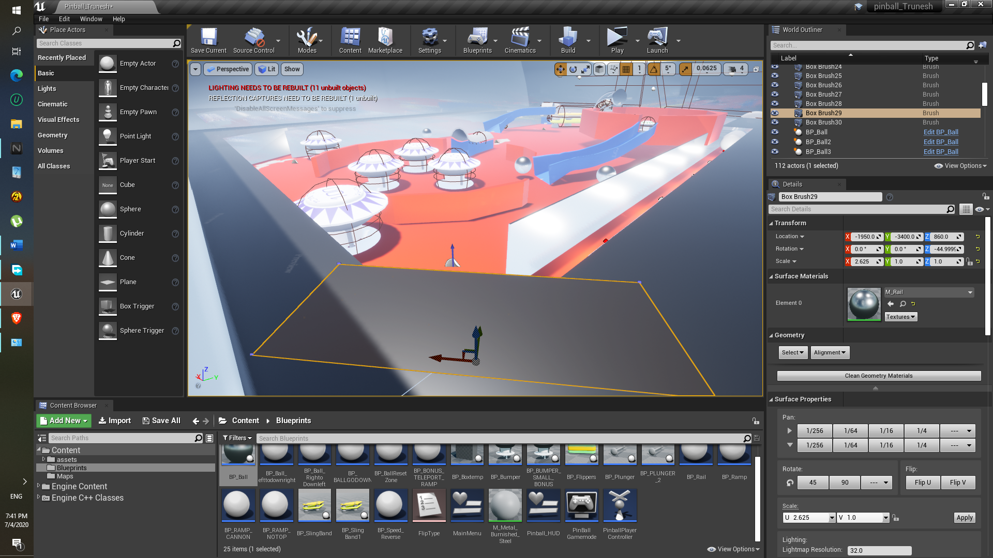

1. Another geometry box is added , So that after ball impacts on that box, it can get inside the main region of the pinball game

**Result:**

1. Successfully able to create the plunger part via using the Subtractive geometry brush ,
2. Added the point light and duplicate it via pressing the alt key and by dragging it.

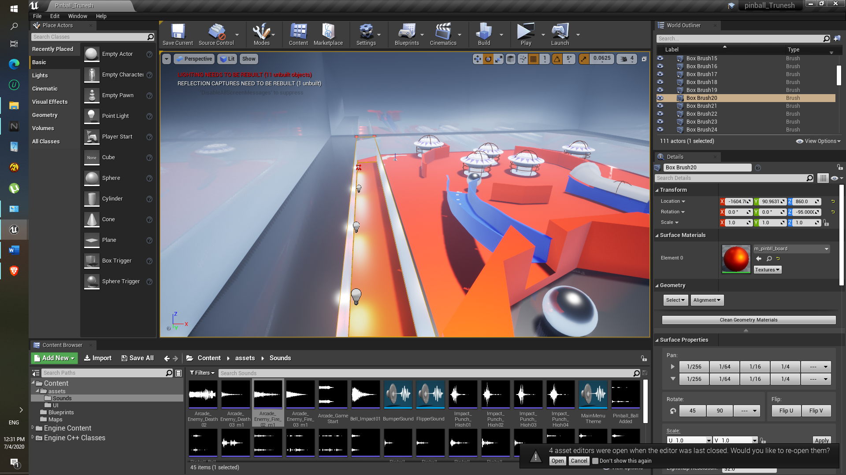

**Component: Ball**

**Approach:**

1. Ball has to move in downward direction so the constant impulse is added in downward direction, in my case the +ve Y-axis.

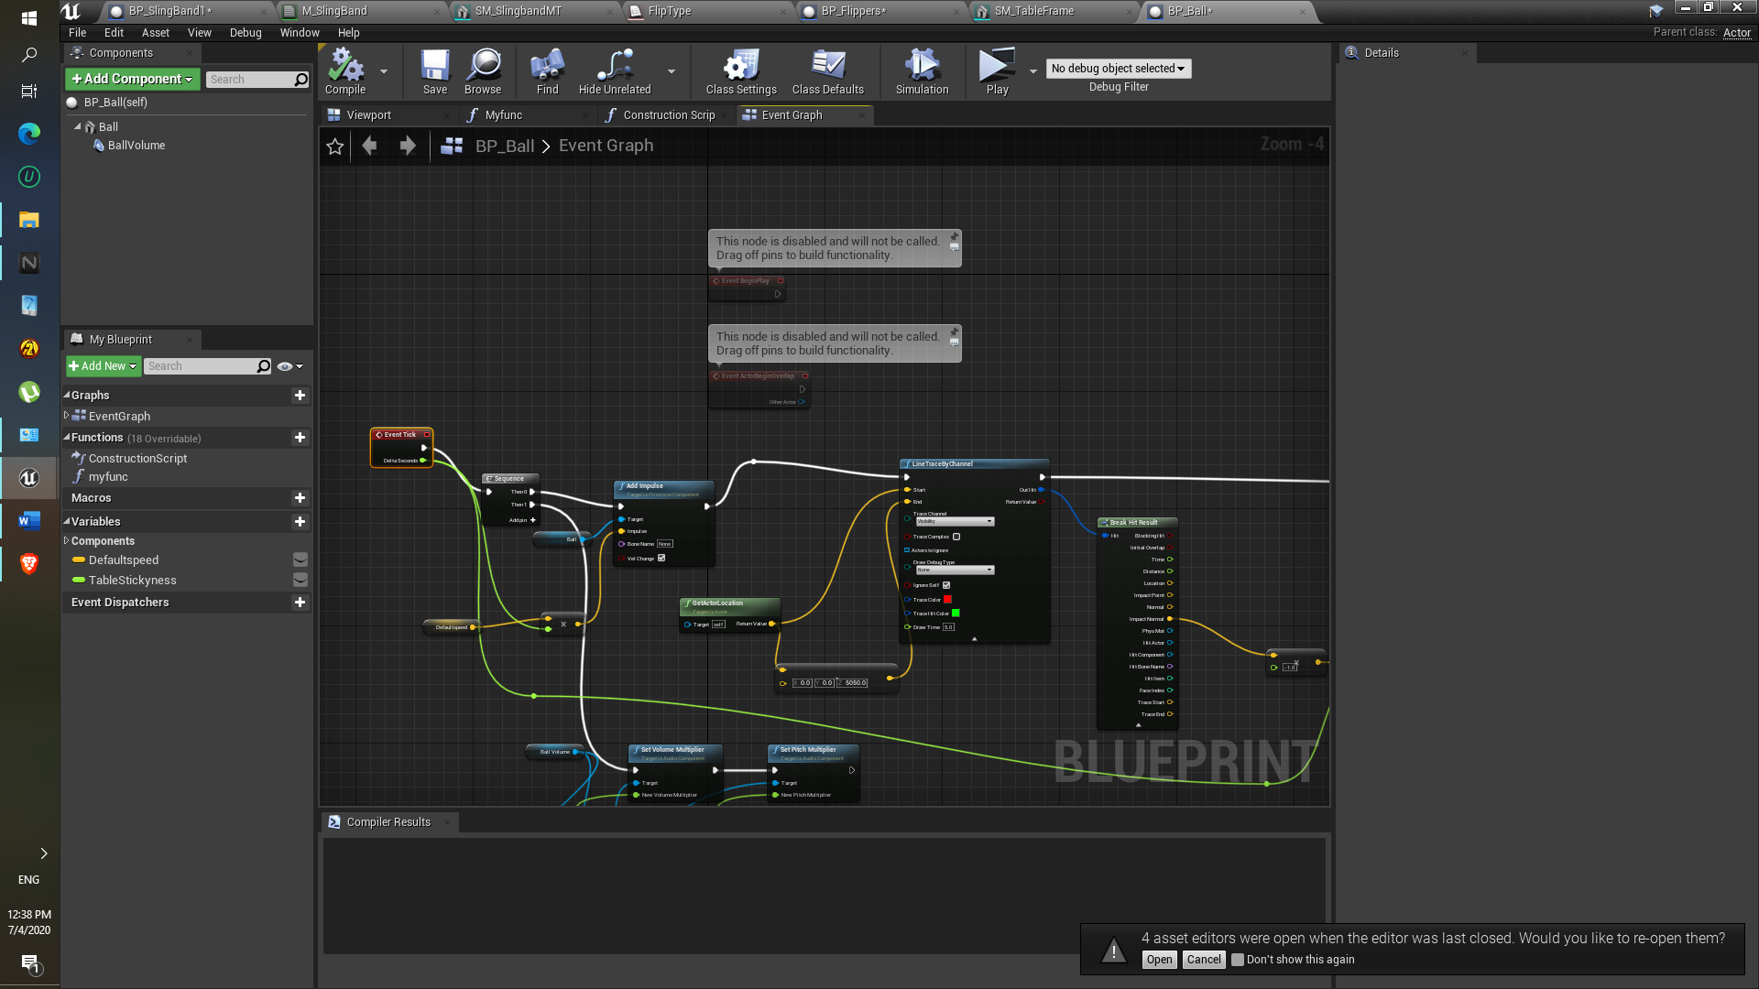

1. At each event tick ball will have the the downward direction speed.
2. Another component is used here which is the LinetraceByChannel.
3. In linetraceByChannel’s ‘Impact normal’ help the ball to stick to the ground.

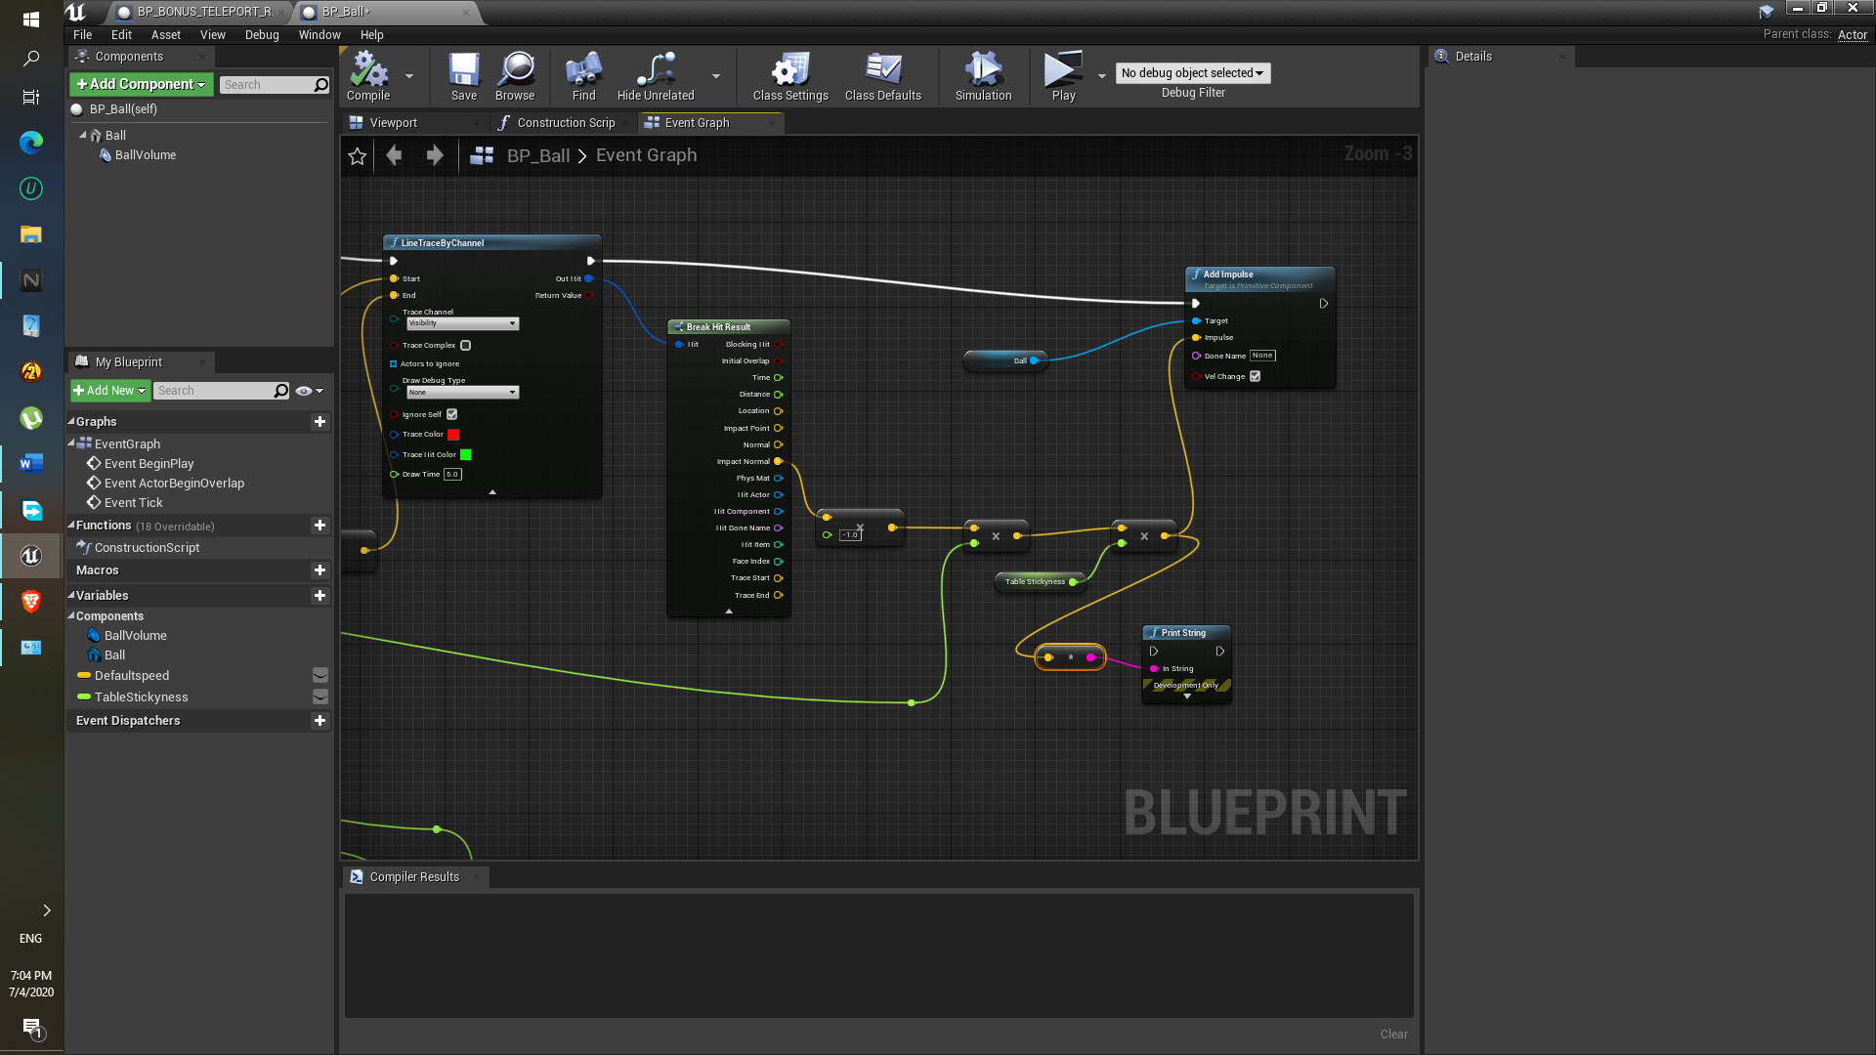

1. In above image the it is multiplied with -1 so that it will go downwards direction.
2. Event tick is multiplied with the vector because if the machine produce lag or something. it will keep ball at proper position.

**Result:**

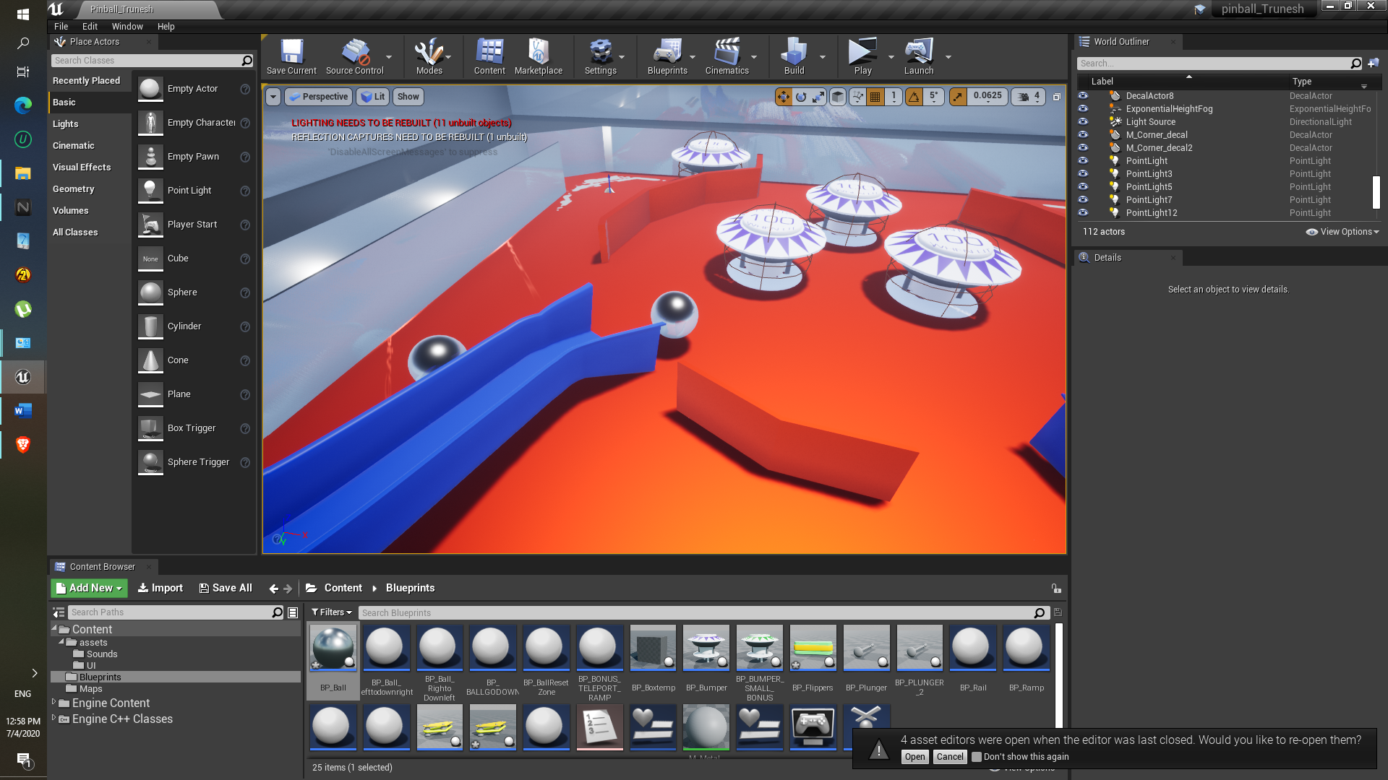

**Difficult**:

Ball still flies for some reason. If I increase stickiness, ball speed gets decreases and if flipper hits it, it goes slow in opposite direction because of flippers. That’s why I did not increase the table stickiness. Even now ball still flies off.

**Additional Changes:**

So fix that issue. I just added Empty blueprints in the Centre of the whole table frame and also two blueprints at the left and right side of the flipper.

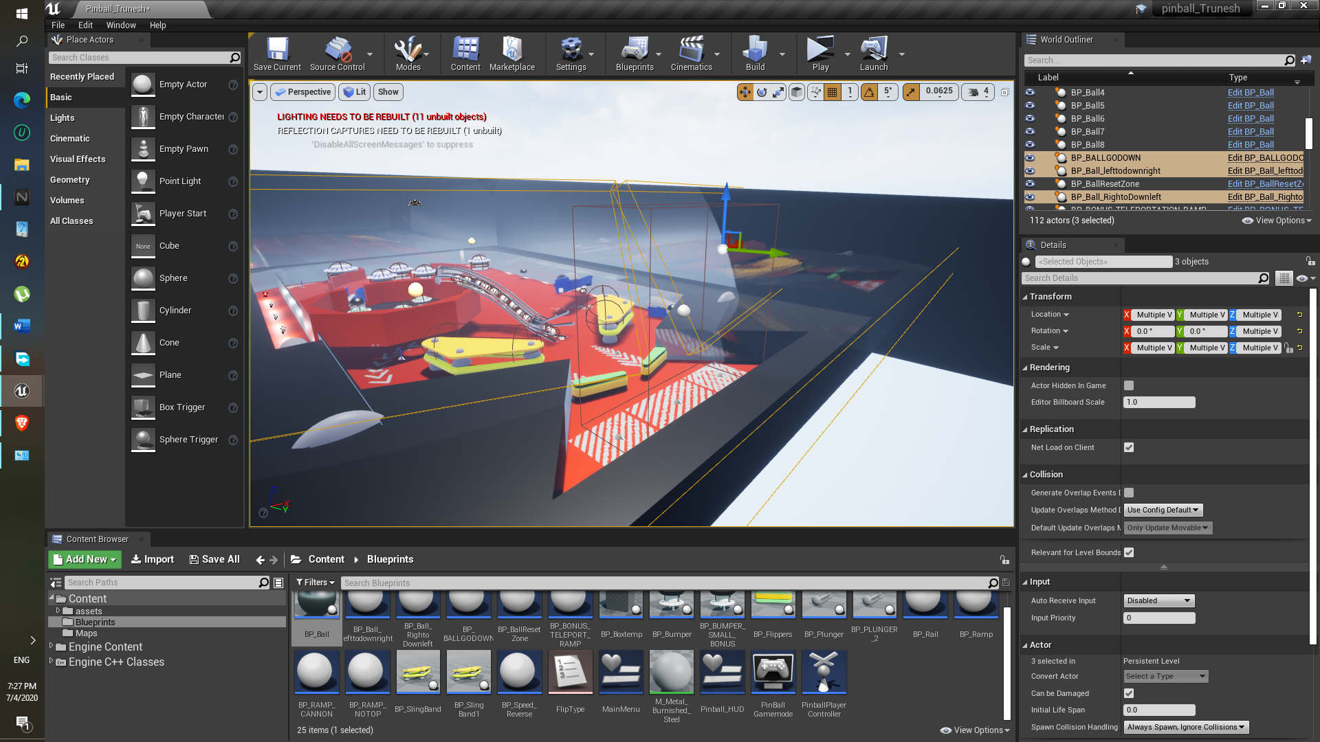

Both left- and right-hand side Blueprint box add impulse towards centre of the board, ball again gets inside the region.

**Component: Flippers Sound**

1. Approach here I used the single sound cue, so if we set parameter that sound will be played.



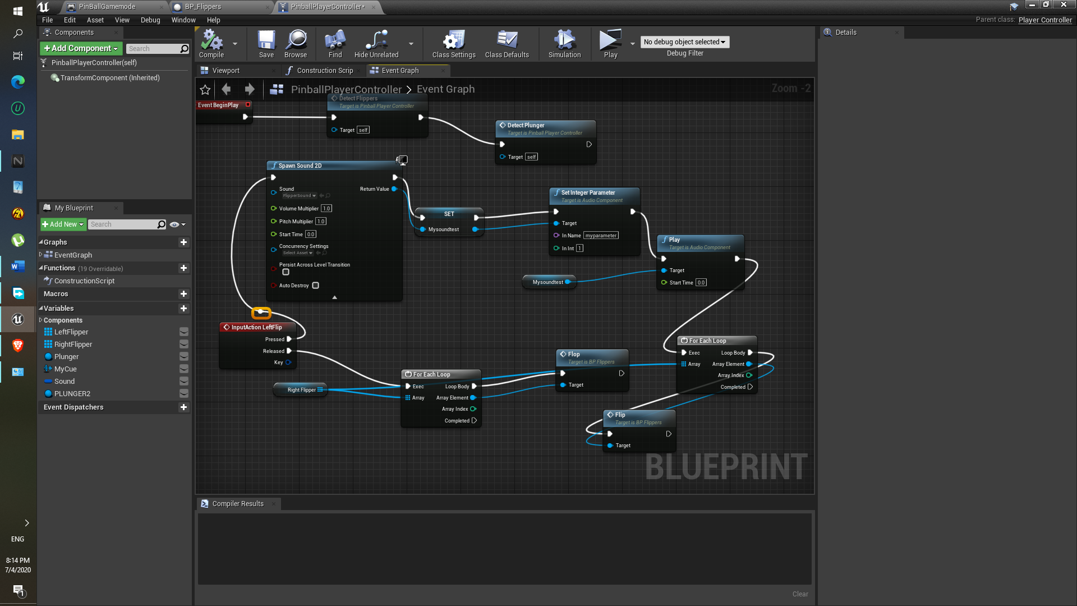

1. Here the Switch is added having unset,0,1 parameter ( unset and 0 has to be connected to the same sound else it wont work)

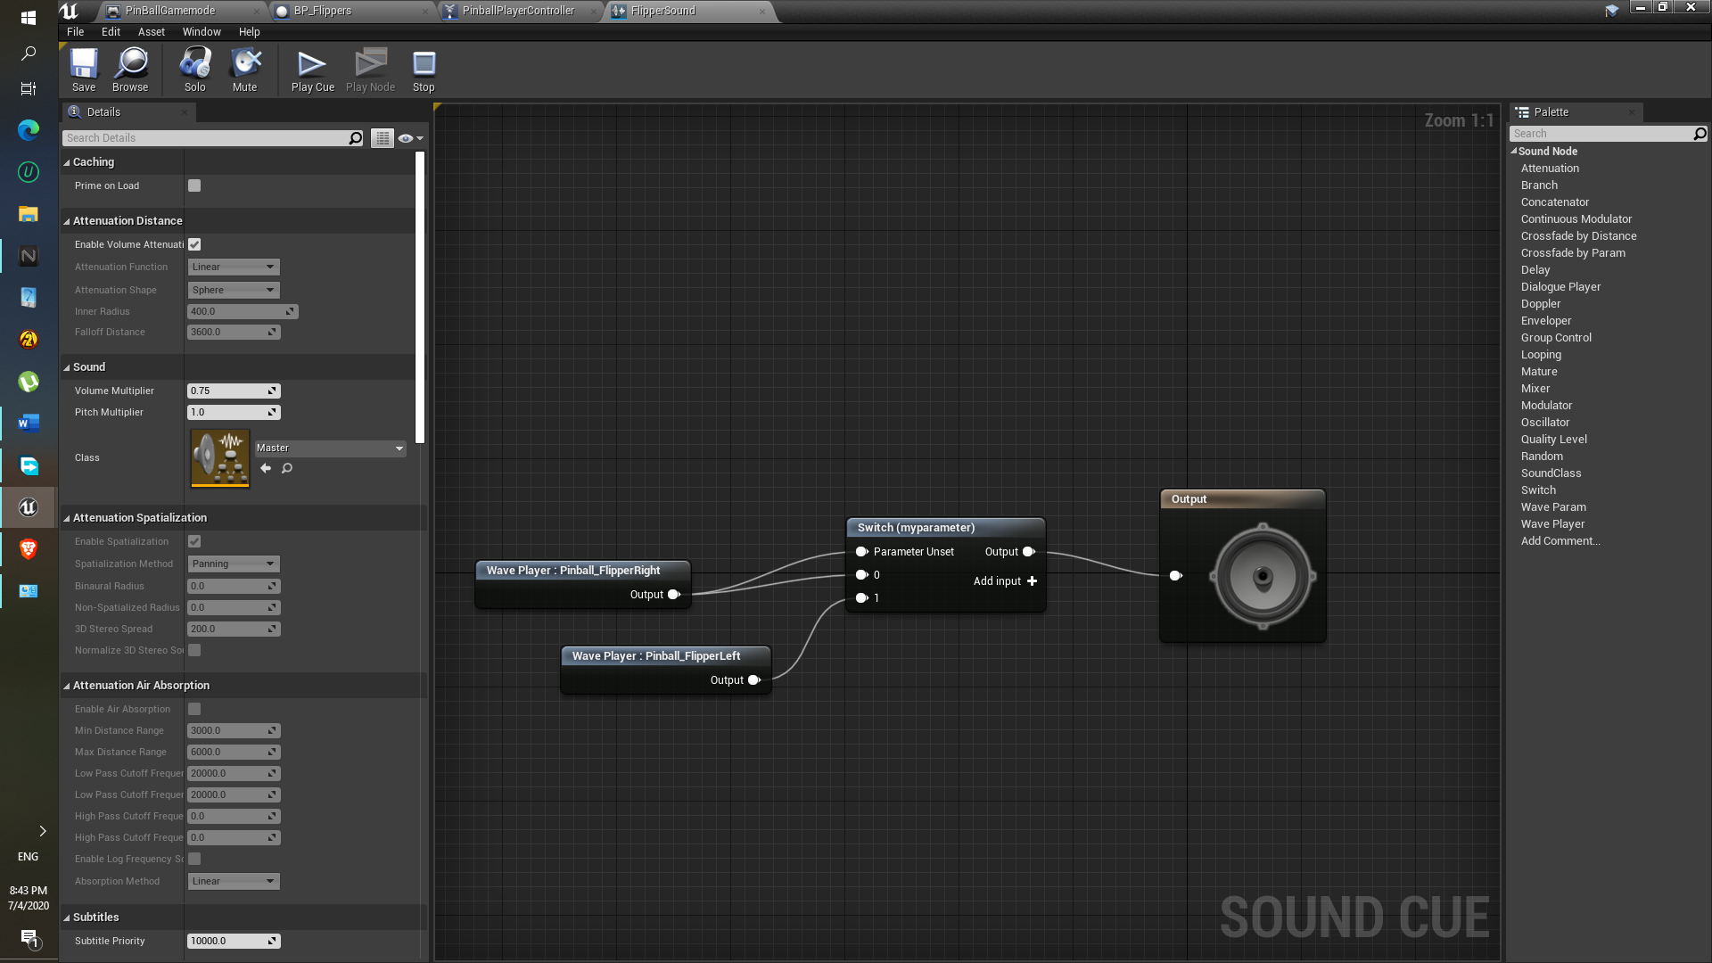

**Component : SlingBand Sound**

**Approach:**

1. Directly sounds are drag inside the sound cue.
2. Random is used… so that anyone of the sounds will be played.

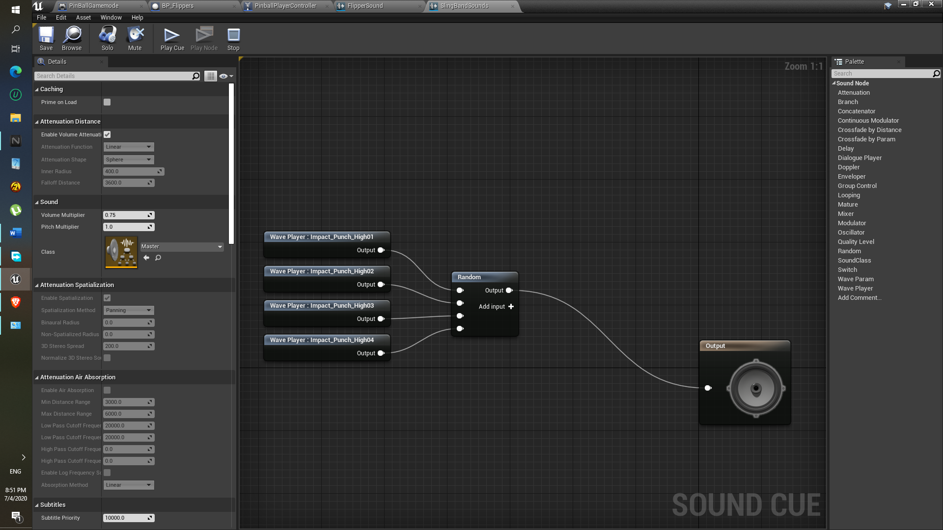

**Component : Main Menu Sound**

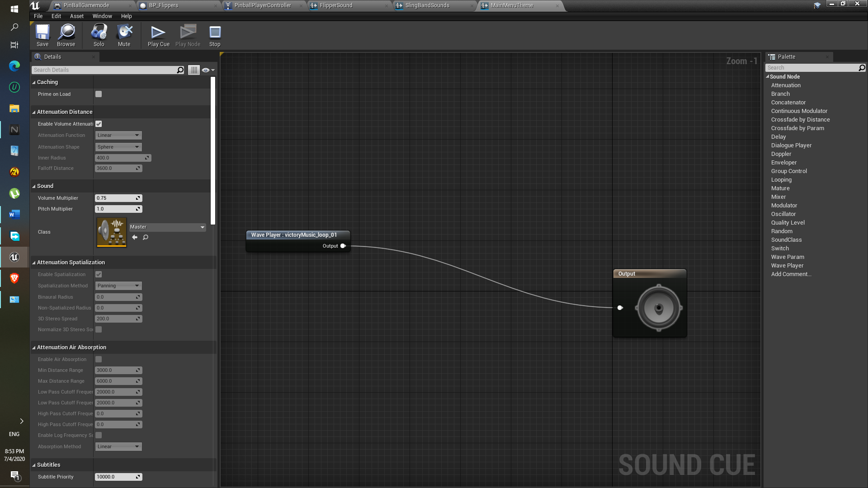

**Approach:**

1. Here sound will be played in a loop won’t stop.
2. As soon as played on play button , the Main menu theme sound component will be destroyed and the another sound PinballPlayStart will played.

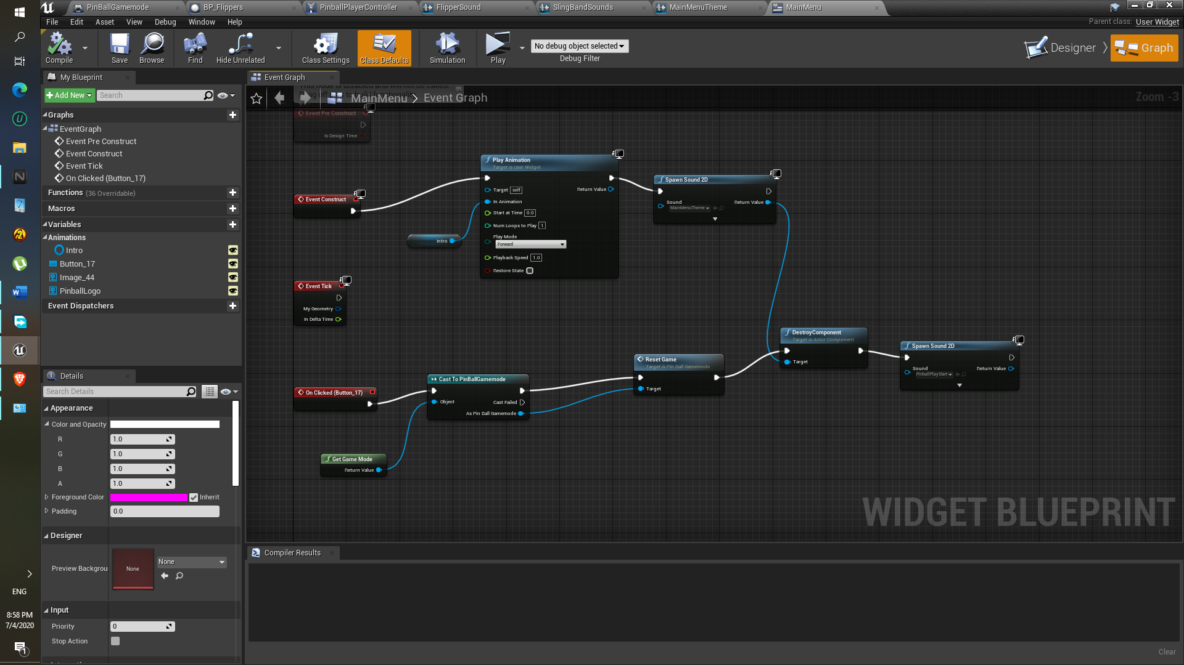

**END**